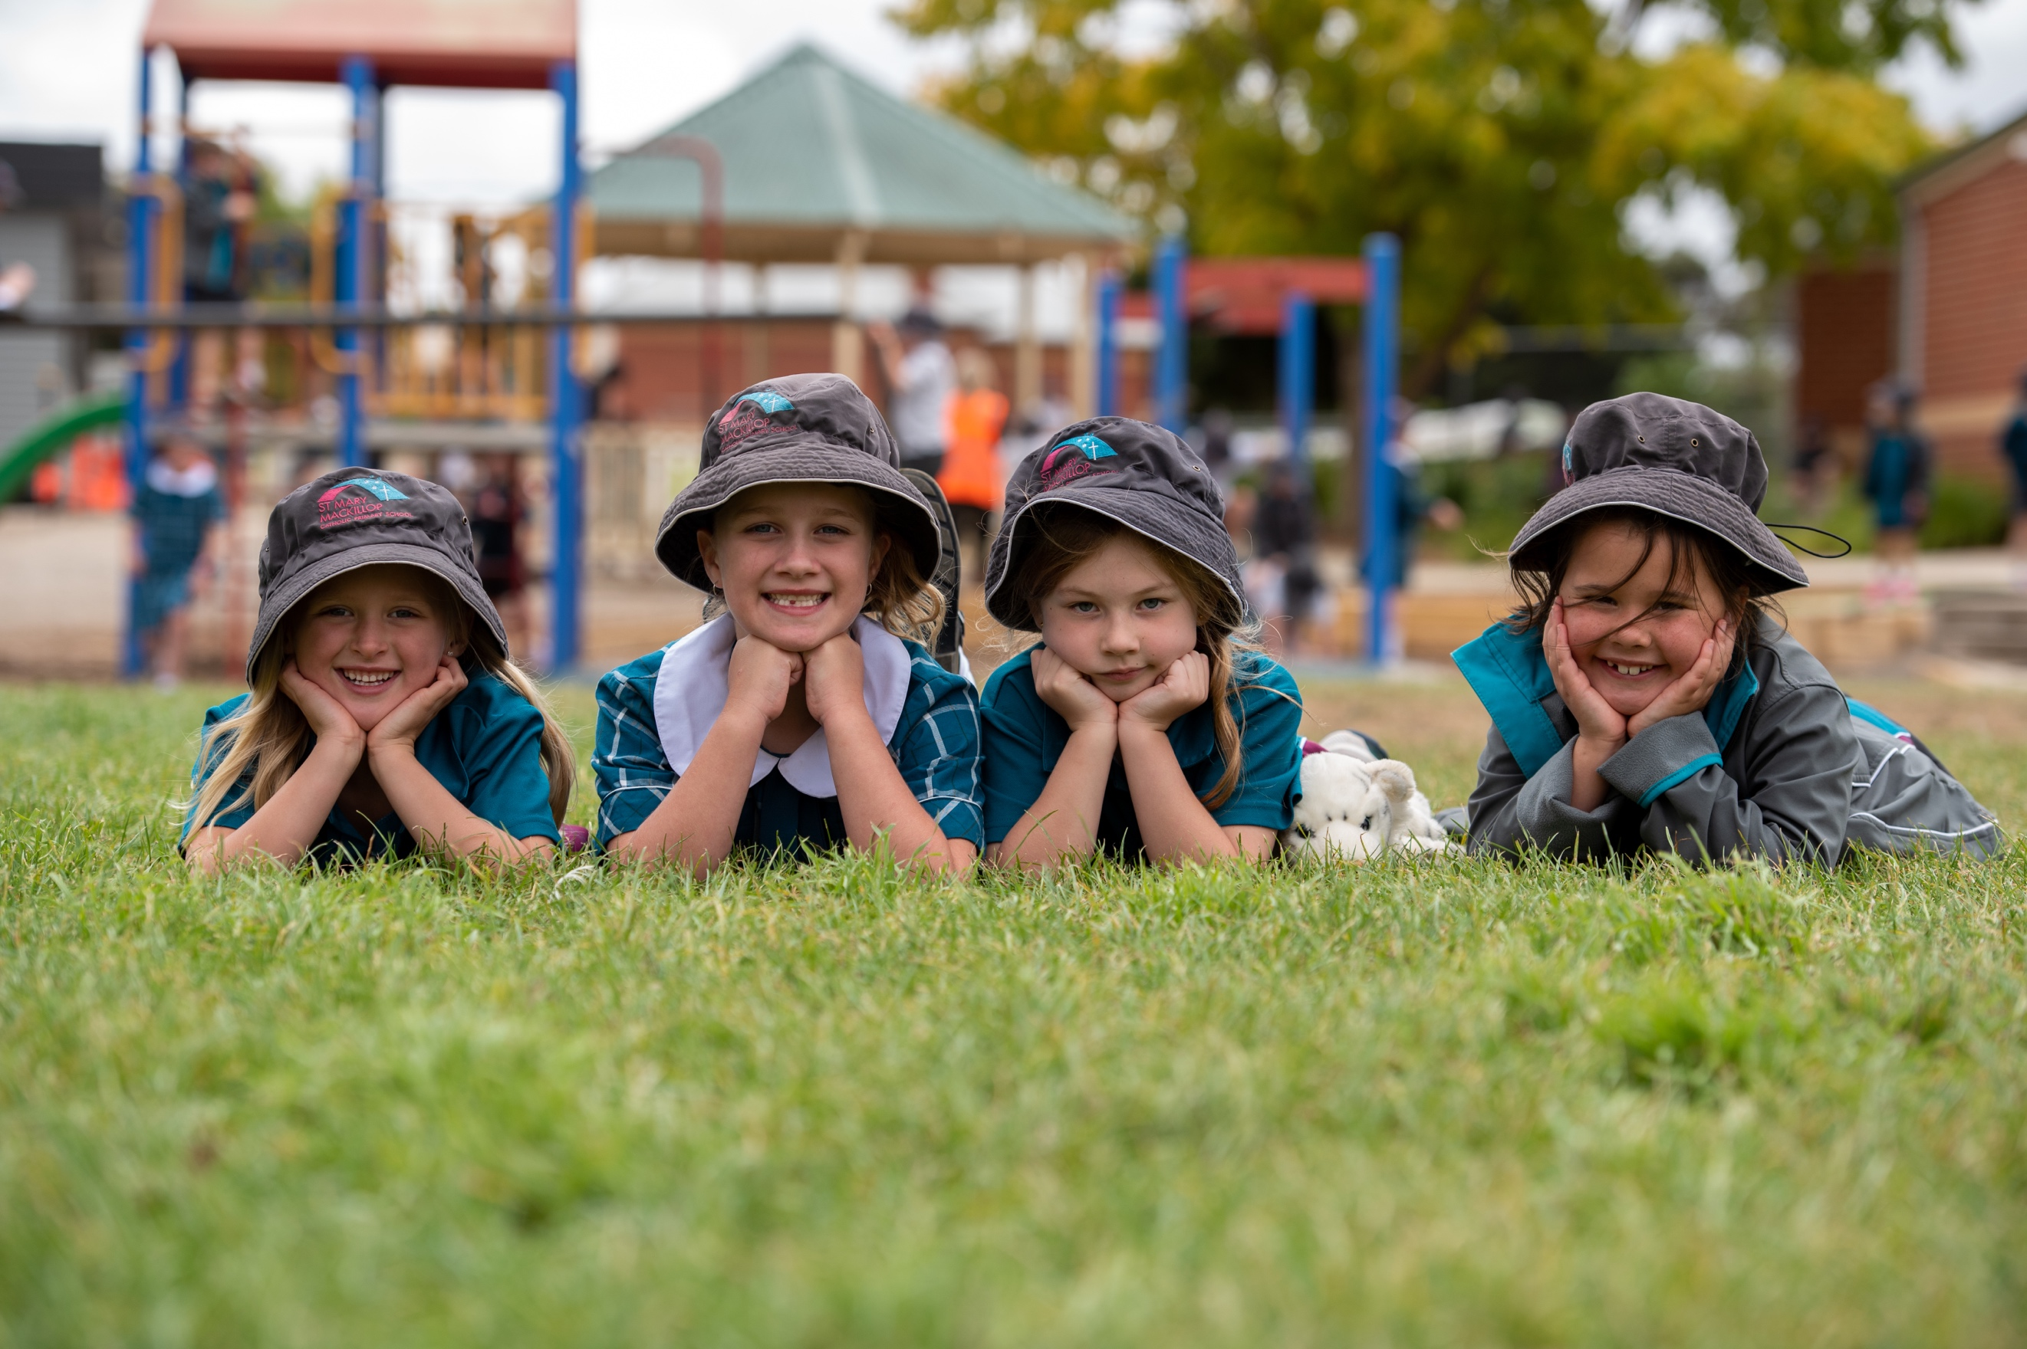
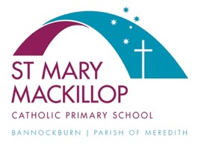
Parent Handbook
2023
St Mary MacKillop
Catholic Primary School
Bannockburn

Table of Contents
Welcome Letter from Anthony 4
Welcome Letter from Fr Charles 5
SCHOOL INFORMATION 6
St Mary MacKillop Catholic Primary School 7
St Joseph’s Parish Meredith 7
School Staff for 2021 8
Dates and Times for 2021 9
Term Dates & Public Holidays 2021 9
INFORMATION FOR FOUNDATION (PREP) PARENTS 10
Advice For Parents of Prep Children 11
SCHOOL PROCEDURES 13
Assemblies 14
Buddy Program 14
Book Club 14
Bus Information 14
Change of Details 14
Children’s Property 15
Dogs In The School Yard 15
Dismissal Procedure 15
Enrolment Procedure 16
Extended Absences From School 17
Expectations of Parents 17
Home Learning 18
Lost Property 18
Lunch Orders 18
Mobile Phones & Smart Watches 18
Outside of School Hours Care 19
Parent Calendar 19
Privacy Policy 19
Problems – If a child has a problem 19
Punctuality 19
School Crossing 20
School Fees and Levies 20
School Hours 21
Secondary School Enrolment & Transition 22
Uniform 22
Visitors to the School 23
Volunteering at School 24
Website http://stmmb.catholic.edu.au/ 24
Yard Duty 24
STUDENT HEALTH AND WELLBEING 26
Active Travel 27
Anaphylaxis 27
Asthma 28
Bullying and Harassment Prevention 28
Child Safety Standards 28
Community Code of Conduct 29
Court Orders 29
Head Lice 29
Immunisation & Infectious Diseases 29
Medication 30
School Counselling Services 30
School Nurse 31
School Speech Pathologist 31
Sick Children 31
Sunsmart 31
Support for Students with Additional Needs 31
CURRICULUM PROGRAMS 33
Curriculum 34
Camp Program 34
Excursions 34
Interschool Sport 35
Religious Education 35
Reporting Children’s Progress to Parents 35
Sacramental Programs 36
Student Leadership 36
Transition Programs 36
PARENT & COMMUNITY INVOLVEMENT 37
Classroom Helpers 38
Communication 38
Parents and Friends Association 38

Welcome Letter from Anthony

Dear Parents,

It is my privilege to extend you a warm welcome to St Mary MacKillop Catholic Primary School, Bannockburn. We hope that all who are associated with this school find it to be a faith-filled environment where Gospel values are lived.

We especially welcome all families who are new to the school and/or new to the area.

Beginning the journey at a new school is a time of excitement, of expectations and of hope that the years ahead will be ones that you will enjoy. We hope that you feel welcome in our community of St Mary MacKillop and will be able to look back on your time here with fond memories.

At St Mary MacKillop we strive to make these hopes a reality. We have a dedicated staff who with many years of experience are able to offer:

- A welcoming, friendly atmosphere
- A Gospel based approach to all that we do
- Learning Communities based around a personalised learning environment
- A caring and happy school, where the wellbeing of all children is paramount and all children are treated with respect
- The chance for children to perform to the best of their ability

St Mary MacKillop Catholic Primary School came into being in 2018 after many years of campaigning from the parish for a primary school in the parish. The move of Bannockburn Primary school to the new P-12 College left a school ready for renovation and a new chapter in its life. After a very quick but wonderful renovation during the 2017-18 Christmas period St Mary MacKillop opened in late January with 75 children from Prep – Year 6. In 2023 we will have grown to 360 children with more growth to come.

As a Catholic School, we value our rich religious traditions and culture. We provide opportunities for our children and their families to celebrate our Catholic heritage, in many different sacramental and non-sacramental ways.

At St Mary MacKillop we value parents as an integral part of the child’s education and therefore are keen to build partnerships with all of our families

As a school community, we look forward to joining with you in the educational journey of your child. We value your input and look forward to an open and honest dialogue over the years ahead.

We hope you enjoy your time at St Mary MacKillop Catholic Primary School and feel part of the community.

Yours Sincerely,

ANTHONY DRILL
PRINCIPAL

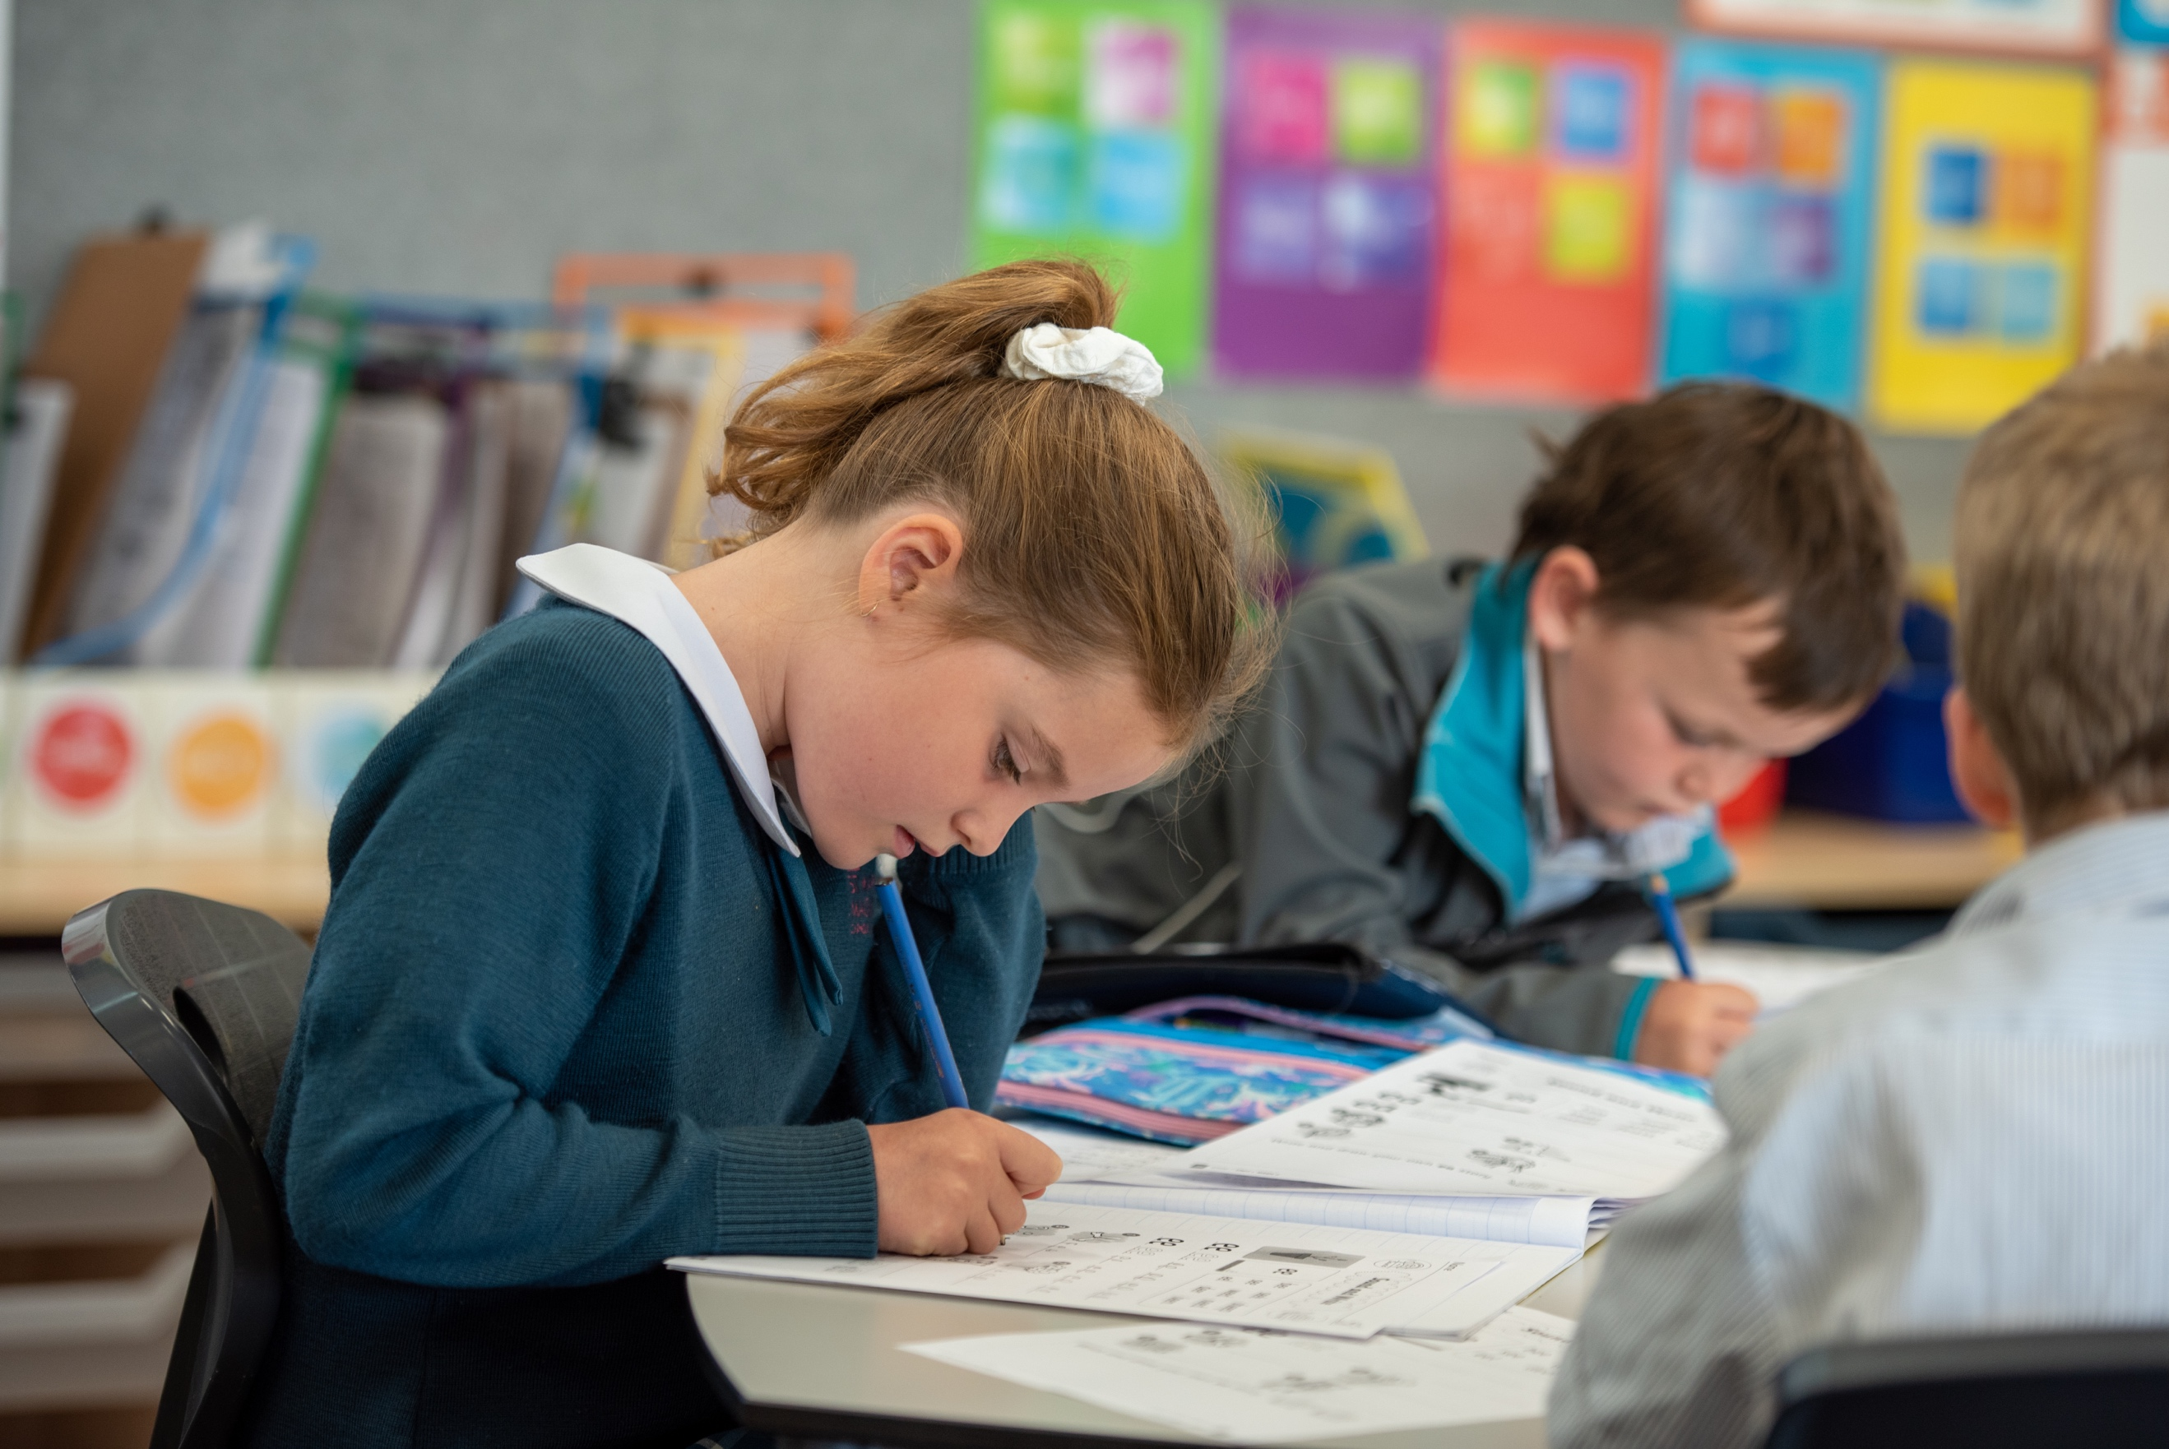
SCHOOL INFORMATION

St Mary MacKillop Catholic Primary School

Principal Mr Anthony Drill
Deputy Principal Mrs Kylie Stephens

Office Manager Kirsty Palimaka
First Aid & Admin Assistant Alison Holmes
School Nurse & Admin Assistant Michelle Thomson
Administration Assistant Renee Gleeson
Accounts Irene Fish

School Office Hours 8.30am to 4.00pm daily

School address 15 Milton St Bannockburn Victoria 3331
Postal Address P.O. Box 347 Bannockburn 3331
Telephone (03) 5281 8500

E-mail principal@stmmb.catholic.edu.au
Office office@stmmb.catholic.edu.au
Web address www.stmmb.catholic.edu.au

Facebook St Mary MacKillop Catholic Primary School Bannockburn

St Joseph’s Parish Meredith

Parish Priest Father Joseph Panackal

Parish Address 28 Lawler St Meredith Victoria 3333
Postal Address PO Box 40 Meredith 3333
Telephone 5286 1230

Email parishofmeredith@bigpond.com

School Staff for 2023
NAME | RESPONSIBILITY
Anthony Drill | Principal
Kylie Stephens | Deputy Principal
Katrina Frewin | Religious Education Leader
Sharon Dow | School Literacy Leader
Jacqui Beasley | Wellbeing Leader
David Tripodi | Mathematics Leader
Tess Cartwright | School Improvement Leader
Tamara McGuire | Learning Diversity Consultant
Kate Lee | Prep Teal Teacher
Millie Deeath | Prep Burgundy Teacher
Kerrie Emmett | Prep White Teacher
Christina Hughes | Prep White Teacher
Ellie Clarkson | Year 1 Teal Teacher
Simone Norman | Year 1 Burgundy Teacher
Liz Buller | Year 1 White Teacher
Claire Palmer | Year 2 Teal Teacher
David Tripodi | Year 2 Teal Teacher
Klaire Ladgrove | Year 2 Burgundy Teacher
 | Year 2 White Teacher
Taylah Williams | Year 3/4 Burgundy Teacher
Georgina Blue | Year 3/4 Teal Teacher
Alayne Heath | Year 3/4 White Teacher
Daniel Bunworth | Year 3/4 Grey Teacher
Jeremy Lumsden | Year 5/6 Teal Teacher
Narelle Nixon | Year 5/6 Burgundy Teacher
Andrew Snape | Year 5/6 White Teacher
Alanna Butcher |  | Release Teacher
SPECIALIST TEACHERS
Carla Radalj | Phys Ed Teacher & NCCD Release
Mikayla Thomas | Performing Arts Teacher
Belinda Zangari | LOTE Teacher
Alison Partridge | Visual Arts Teacher
Lia Lowe | STEM
LEARNING ENHANCEMENT TEACHERS
Lynda Tonkin | Year P-2 Learning Enhancement
Ash Hunter | Year 3- 4 Learning Enhancement
Zoe Vagg | Year 5 - 6 Learning Enhancement
LEARNING SUPPORT OFFICERS
Annette Sexton | LSO Prep Burgundy
Jodie Trifiletti | LSO Prep Teal
Kayla Lavell | LSO Prep White
Elisha hill | LSO Year 1 Burgundy
Laura Sweeney | LSO Year 1Teal
Imogen Dow | LSO Year 1 White

School Staff for 2021 (Continued)

LEARNING SUPPORT OFFICERS (CONTINUED)
Erica Colla | LSO Year 2 Burgundy
Marijana French | LSO Year 2 Teal
Jack Wrigglesworth | LSO Year 2 White
Audra Curypko | LSO Year 3/4
Catherine Bomm
Michael Jeffrey
Nicola Trickey
Gus McKinnon | Year 5/6 LSO
Kim Ellis | Year 5/6 LSO
Tessa Andrews | Psychologist
Kim Schwarz | Speech Therapist
Kirsty Palimaka | Office Manager
Irene Fish | Office Assistant
Ali Holmes | First Aid & Office Assistant
ReneeGleeson | Office Assistant

Dates and Times for 2023

Week 1

Friday 28th January Staff Return to school

Monday 31st January Organising new classrooms

Monday 1st February Preps begin – Preps at school 9.00am – 1.00pm. Children should bring a healthy snack/fruit and drink bottle

Monday 1st February Years 1 – 6 begin – School Assembly on asphalt area at 8.45am

Week 2 – Week 6 Prep children have Wednesday as a Rest Day

Week 7 First Wednesday for Preps

Term Dates & Public Holidays 2023

Term 1 Friday 28th January Staff day
Tuesday 1st February All children return
Monday 13th March Labour Day Public Holiday
Friday 6th April End of Term 1

Term 2 Monday 24th April Term 2 begins
Tuesday 25th April Anzac Day
Monday 12th June Kings Birthday Public Holiday
Friday 23rd June End of Term 2

Term 3 Monday 10th July Term 3 begins
Friday 15th September End of Term 3

Term 4 Monday 2nd October Term 4 begins
Monday 6th November Pupil Free Day
Tuesday7th November Melbourne Cup Day
Friday 20th December End of Term 4

PUPIL FREE DAYS

Pupil Free Days are held to allow staff to attend Professional Learning programs run by staff from the Catholic Education Office and other presenters. Specific dates will be published in Newsletters and Term Calendars. Other Pupil Free days may be organised, and will be communicated to parents through our communication Apps

Please note that any changes or updates are always advertised in the fortnightly Newsletter and via Seesaw

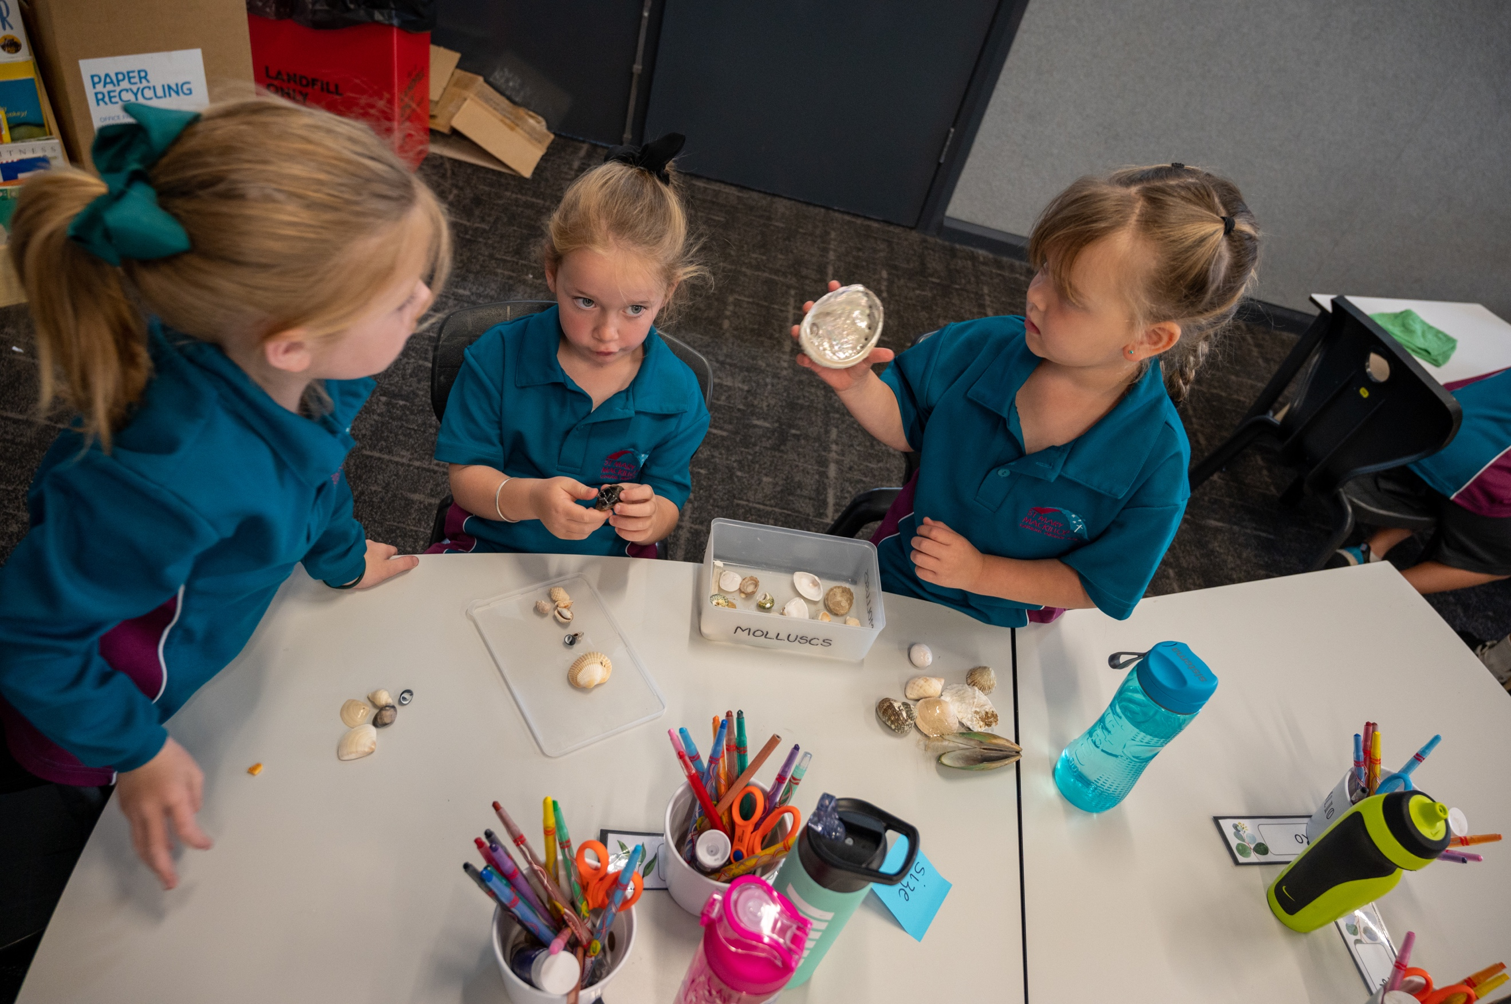
INFORMATION FOR FOUNDATION (PREP) PARENTS

Advice For Parents of Prep Children

Orientation Phase

After your enrolment to St Mary MacKillop Catholic Primary School has been offered and accepted you enter the Orientation Phase of the enrolment.

During November of the previous year to your child entering school, there will be a number of opportunities for your child to come to school and experience what the Prep class is like with all of the other children enrolled for the next year.

Whilst the children are occupied in the classrooms, parents stay for their own Orientation meetings where you will gain valuable information about school, have your questions answered and meet all of the other parents who have children starting school.

Starting School

The following items will be of benefit to your child at school:

- An art-smock
- Change of clothing (underwear, socks, shorts/pants)
- A distinctive label or tag on the school bag
- A distinctive 'name' label on all items of clothing and other items.

Some things to Do and Don’t Do

Do…

- Be patient with your child.
- Ask your child's teacher if there are ways in which you can help
- Value your child's interests and efforts
- Show an interest in your child and in what he/she is doing
- Share books and stories with your child
- Be a good listener
- Encourage your child to read to you
- Try to provide your child with interesting reading material
- Contact the relevant teacher if you are at all concerned about any matter.

DO NOT Become over-anxious about your child's academic progress - all children are individuals and develop in different ways and at different rates, therefore ...

Do Not…

- Compare your child's progress with that of his friends, or other children
- Expect more from your child than is reasonable
- Force your child to read to you or expect learner readers to be word perfect
- Expect your child to tell you all about school every day
- Talk about your child's problems in front of him (or other children).

Settling In

No matter how much your child looks forward to school and how happily they set off on the first day, the actual separation from you may bring tears and clinging. If this does happen, give them a big hug and a kiss, tell them you will see them after school, say goodbye warmly but firmly, and go. Upset children usually stop crying as soon as mum or dad is out of sight.

Parents are asked not to come to school during lunch or recess breaks time as this can be very unsettling for a child and cause them distress. This is especially the case for children in Grade Prep.
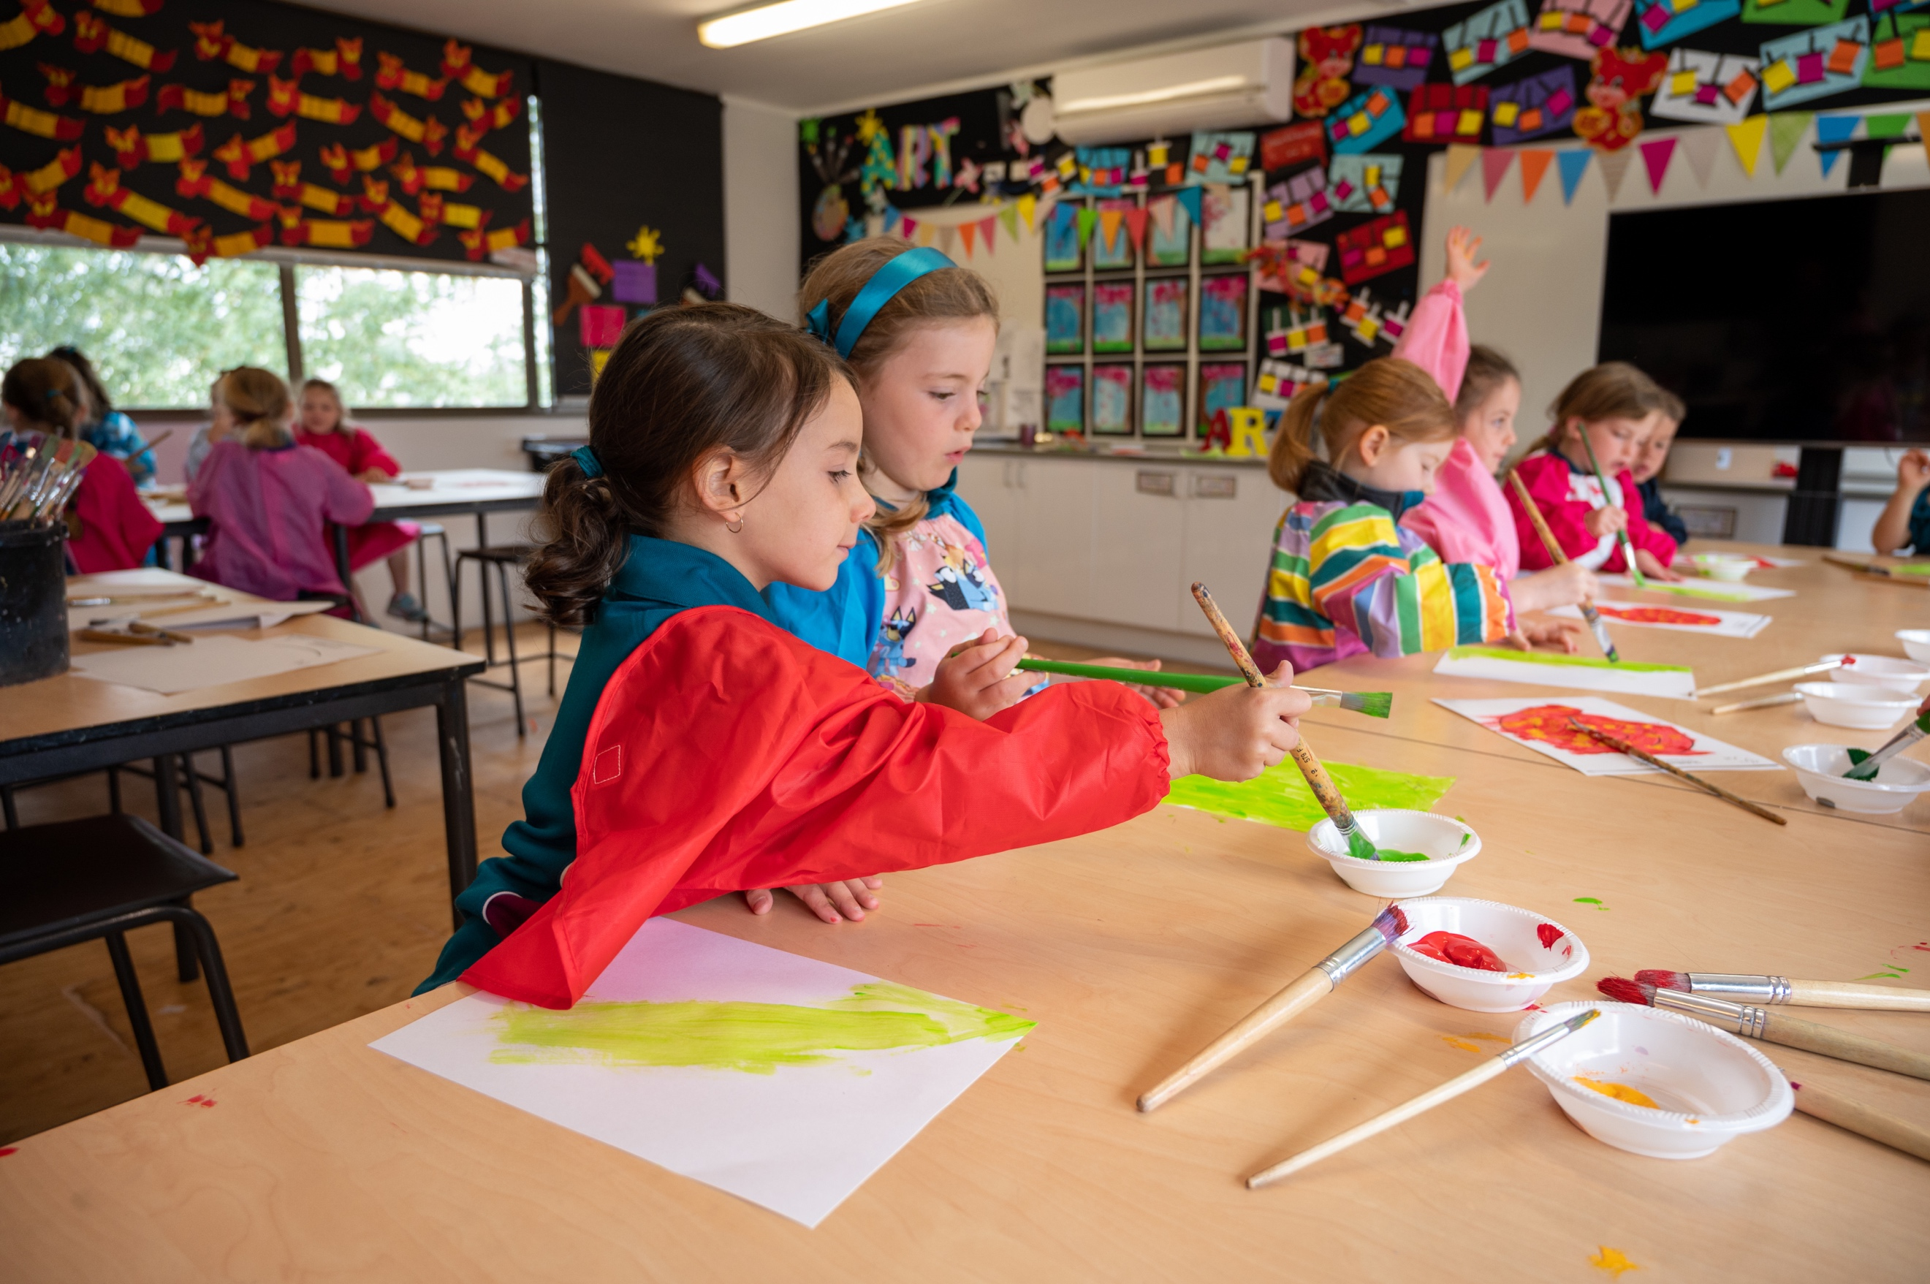
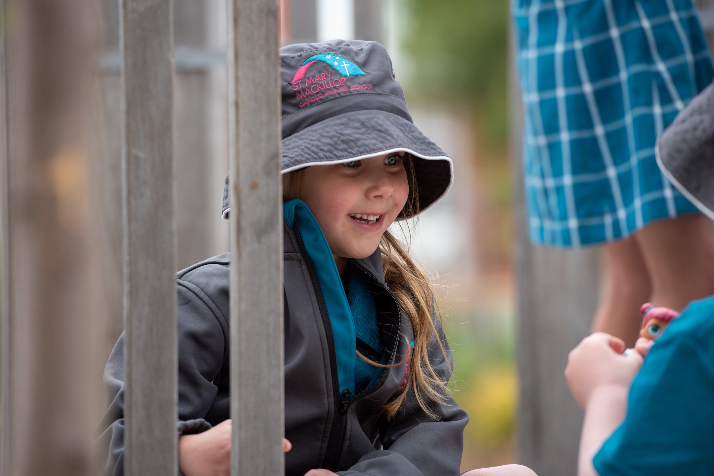

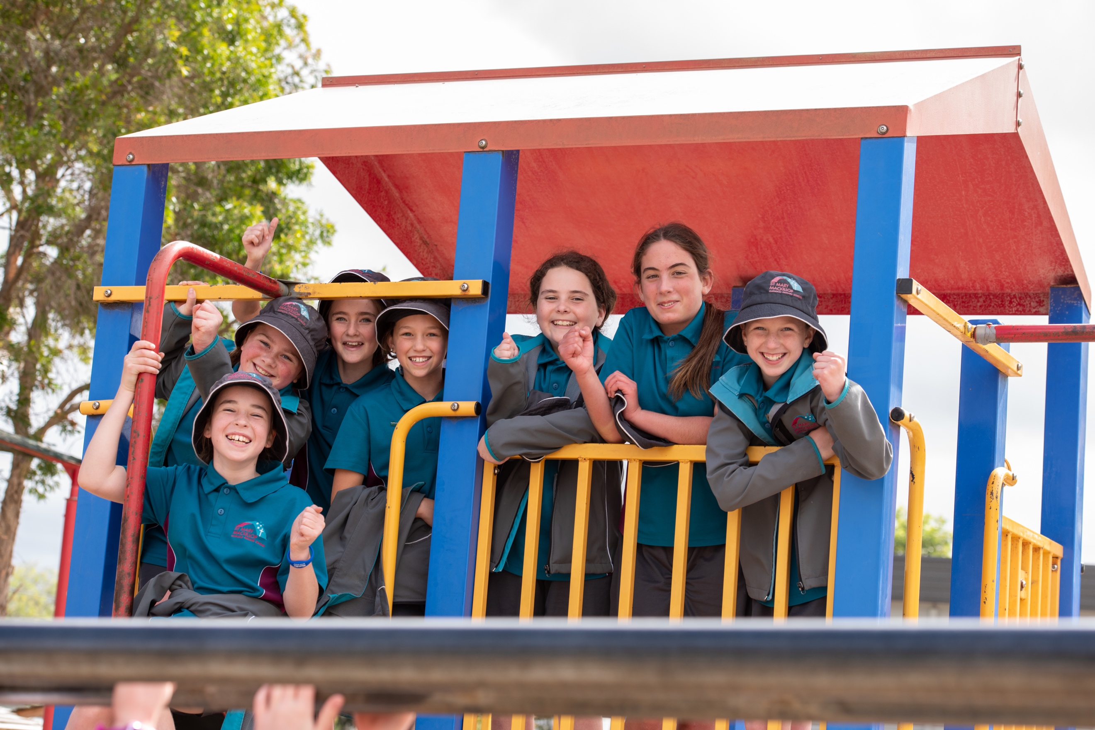
SCHOOL PROCEDURES

Allied Health Appointments

St Mary MacKillop CPS values the partnerships with outside Allied Health personnel and is happy to facilitate some of their appointments with children at school during school time. We are very limited with space that is suitable for appointments to take place. In 2023 we are predominantly offering Monday as the only real option as there are some spaces available on this day. Whilst we attempt to accommodate all Allied Health personnel it is sometimes not possible due to constraints on space and times that the person can work. Kylie Stephens, Deputy Principal is tasked with coordinating the timetabling and maintaining all appropriate letters, certificates, insurances etc. Please contact her for more information. There is a procedure to follow when booking in new Allied Health to our school. Kylie will be able to lead you through this.

Assemblies

Assemblies are held once a fortnight. Assemblies will be held on Monday afternoons at 2.30pm. The actual days will be communicated in the Parent Calendar and in Newsletters. Assemblies are held in the church and parents are very welcome and encouraged to attend. Each Year Level takes it in turn to conduct the assembly, showcasing some of their work.

Prayer is an important part of our school life and we open each of our assemblies with a prayer, acknowledgement of country and our National Anthem. Student awards are also presented at Assembly.

Buddy Program

In order to assist prep students to settle into the new environment, a 'Buddy' program is put into place. Children from prep are paired together with a Year 5/6 child. The buddy student helps to ensure that the younger children are able to manage the playground and general school surrounds. The buddy students may also assist the younger children in class during structured activities.

The advantages of the Buddy program include:
- Prep children are made to feel more welcome and safer at school.
- Prep children see a familiar face in our large school playground.
- The younger children have an older role model that they can look to for assistance.
- Senior pupils develop leadership, maturity and communication skills.
- Positive role models are established.

Book Club

Children are given the opportunity to purchase reasonably priced books through the Scholastic Book Club. There are 8 issues per year, 2 every term. The school provides this as a service for the purpose of promoting reading.

Scholastic Book Club offers a range of texts selected for each level of the school.

Book orders are submitted on the Book Club order forms online and books are sent home when they arrive. Participation in the book club program is voluntary. The school also benefits from this program by earning points that go to purchasing resources for the classrooms.

Bus Information

Children who attend St Mary MacKillop are able to access the free bus service that brings children into Bannockburn P-12 College from surrounding areas if there are places available. If you would like to know more information about eligibility, please see Kirsty or Ali at the office for enrolment forms. All forms are returned to us and then the Bus Co-ordinator at Bannockburn College arranges all of the rest.

The drop off and pick up points for the Bus children is Milton St. Children are dropped off and met by a staff member in the morning. In the afternoon bus children gather with the staff in charge of the bus and are walked to the bus/es that will take them to Bannockburn College where they board the correct bus for their route.

Change of Details

It is the responsibility of the parent to keep all of their details including address, email, phone, work contact, emergency contacts, family status, court orders etc up to date with the school as they change. Notifying the school of changes as they occur mean that in case of emergency the school will be able to contact parents or emergency contacts when needed.
There are a number of ways to change details.

- Contact the office in person, via phone or email to update the details.
- Change the details in Operoo. This triggers an email to the office and they will update the details.

At re-enrolment towards the end of the year, the school will ask all families to check and update any details that have changed during the year that have not been updated or missed by the school.

Children’s Property

It is strongly recommended that children do not bring toys to school, especially expensive ones. Bringing sporting equipment from home e.g. balls is also discouraged. The school will supply sporting equipment through a borrowing system at recess and lunchtime. However, children may bring items for ‘class news’. No responsibility is taken by the school for items brought to school. Before personal items are sent to school, it is wise to get some guidelines from teachers on:

- Which day class news is on.
- What sorts of items are suitable.

Our aim is to avoid loss or damage to property and avoid causing upset to children.

Ultimately, the permission of class teachers (or other staff) should be gained before private property is brought to school.

If a teacher decides to confiscate an item, the usual procedure is to return the item directly to parents at the end of the day. However, if the item is very unsafe/totally unsuitable, it will be handed to the Principal who will in turn contact parents.

Items which become ‘fad’ items may be banned from time to time. These may include items such as swap cards etc. The reason for banning such items is to avoid inappropriate behaviour e.g. small children being conned or intimidated by other children. Advice will be given in the Newsletter and Seesaw on such bans.

AT NO TIME should children bring any of the following to school:

- Mobile phone (unless parents require children to have them for safety reasons)
- Electronic Game devices
- Toy guns, swords or violent toys

Dogs In The School Yard

We recognise that dogs are an integral part of some families and that a walk to and from school is excellent exercise for the family and the dog. However, dogs are not allowed on our school site as we have a Wellbeing dog, Tilly as part of our wellbeing team. The Dogs Connect regulations stipulate the school site is reserved for the wellbeing dog only. All dogs will need to remain outside of the school grounds for the safety of all children and our wellbeing dog. Please ensure the safety of everyone within the school community by having your dog well controlled, on a lead and being cared for by an adult.

Dismissal Procedure

At the bell time, children are walked out on to the school grounds by their teacher and dismissed from there. Children can exit the school grounds via gates accessed on High St and two on Milton St – the office and bike shelter.

Bus Children will be collected by a staff member at bell time and delivered to the bus.

Children going to After School Care will move to the After School Care area and be marked off the roll.

Early Dismissal

If children are to be picked up before the end of school (for medical or dental appointments etc.) parents should alert the teacher of an early dismissal and the time of collection via Seesaw. When picking up children on such occasions, parents should report to the office and sign their child out on the iPad and collect an early leave pass. The child will be brought to the office

To avoid disruption to classrooms please note that if children need to be collected early they should be picked up at the end of a learning sessions i.e. 10.40am or 1.40pm. If you intend to collect your child during the lunch break it is advisable to let the teacher know in the morning so that the child’s bag can be packed before they go out to play.

It is the school’s preferred option that all appointments are made after school hours or during school holidays if possible.

Enrolment Procedure

Preps

Enrolments for Prep for the following year open in March of the previous year. Announcements about this will be made on the school Facebook page, in our newsletters and through advertising in the community including Kindergartens.

There will be a number of times where prospective parents can come and view the school and chat with the Principal and Leadership to find out if this is the right school for the child.

Application to Enrol forms can be collected from the office after the open sessions in March and need to be returned by the nominated closing date. Documents including, Birth Certificate, Baptism Certificate (if Baptized), Immunisation Certificate and proof of residence is required with the Enrolment form.

An interview with the Principal and Deputy Principal will take place in term 2 and places will be offered soon after

A number of Playdates will occur where the teachers will get a chance to meet the children early on in the process. A simple Screening test will be conducted by our Speech therapist and another staff member during Term 3.

An Orientation Program will occur in November where the new Prep children will have plenty of opportunities to come to school.

Other Year Levels

Enrolments for children in Prep – Year 6 in a current year can be accepted at any time. Application to Enrol forms are available from the office.

Enrolment forms when returned need to include Birth Certificate, Baptism Certificate (if Baptized), Immunisation Certificate and proof of residence is required with the Enrolment form

An Interview with the Principal will take place and an offer of place made if enrolment is to go ahead.

An Orientation Session for all new children will happen in December.

Extended Absences From School

Parents are required to ensure their child attends school and to provide an explanation for their child's absence from school. The principal must be able to determine from the records if the excuse given was reasonable in terms of the parent meeting their legal obligations.

Parents should inform the school of the reason for their child’s absence so that the school can:
- determine if the child’s absence needs to be excused by the principal, in line with school policy and these guidelines
- determine the appropriate follow up to ensure the child’s education and wellbeing is supported
- record if the parent has a reasonable excuse for not meeting their obligation to ensure their child attends school each day.
- Where possible, parents should inform the school in advance of upcoming absences.

All absences should be communicated to school via the Operoo absence form on the morning of the absence and before .30am.

In case of holidays outside of the school term, parents must first apply for permission from the Principal. If granted then a Student Absence Learning Plan needs to be developed in conjunction with the classroom teacher.

For more information on School Attendance Guidelines please refer to the Department of Education and Early Childhood Development website.

https://www2.education.vic.gov.au/pal/attendance/policy?Redirect=1

Expectations of Parents

St Mary MacKillop CPS has a number of expectations of parents enrolling their children, including:

- respecting and supporting the School's Catholic Ethos and Religious Education Program.
- supporting the school in implementing positive behaviour/discipline.
- that while at St Mary MacKillop CPS (or any event organised by the school) Parents will give a positive example to all pupils who might be present, in such matters as common courtesy, polite/appropriate language etc.
- Not smoking in the buildings/grounds or within 4 meters of any entrance.
- considering the prompt payment of school fees to be a high priority within the family's budget and that problems with fees will be discussed with the Principal.
- attending 3 Way conversations and Parent Support Meetings.
- ensuring their children wear the correct school uniform with pride, and avoid extremes in such matters as hairstyle, fashion items etc.
- discussing any serious concerns they might have about any aspect of their child's education, with appropriate school authorities e.g. The Principal.
- respecting people’s privacy and not uploading photos of St Mary MacKillop students or staff to social media or other internet sites without their permission.
- notifying the School Office immediately when change of contact details occur i.e. phone numbers or change of address. Emergency contact numbers are important when your child is ill or in case of emergency.
- COVID-19 has impacted all of us greatly and it is an expectation of the school that all parents follow the advice given by the school via the State Government or Catholic system which changes from time to time and will be communicated to families.

Home Learning

Home Learning involves children being engaged in learning activities outside of school hours. It provides opportunities for families to be involved in their children’s education and strengthens the partnership between the school and the family. It encourages responsibility for learning to be taken by all, including children, parents and the school.

Home Learning provides an opportunity for children to develop positive dispositions that will assist them as life-long learners. Through Home Learning activities, children are able to consolidate skills and pursue areas of interest whilst informing their families of what they have been learning about at school.

St Mary MacKillop CPS believes that children do enough learning at school and that time after school should be devoted to other family pursuits, e.g sporting, etc. At times some Home Learning activities will be sent home depending on the Year level and the work being undertaken in the class for the children and family to complete.

There is however an expectation that children will be practising their reading every night..

Lost Property

To minimise the amount of lost property that occurs, ALL CLOTHING items should be labelled clearly with the child’s name. Other items such as containers for fruit break, lunch etc should also have the child’s name clearly marked on them. Any property that is lost and has a name on it will be returned to the child when found. Property that is not named will go into Lost Property. Parents are more than welcome to look through the Lost Property cupboard outside the Student Reception entrance for lost clothing etc.

Lunch Orders

St Mary MacKillop CPS does not have a canteen for the children to order lunches from. We do however have agreements with a number of businesses in the town including Sorelle Café and the Bakery. Parents place the order and pay for it at the chosen business and they deliver to school ready for lunchtime. Each has a different menu that has been approved by the school. Lunch order day is Friday only.

Mobile Phones & Smart Watches

Students are not encouraged to bring mobile phones to school unless the parent wants the child to have if for safety reasons e.g. walking to and from school. If children do bring mobile phones to school they are to be switched off and either left in the child’s bag or given to the classroom teacher to look after during the day. The school can take no responsibility for the safety of mobile phones left in children’s school bags. At no time should a child have their mobile phone on them in person or in the classroom space. Children discovered using mobile phones during school time will have them confiscated and returned at the end of the day. There is no reason for a child to be contacting a parent via their mobile or smart watch during the day. All communication with parents needs to go through the teacher or school office. Similarly, no parent should be contacting a child during school time directly.

Smart Watches that can communicate with family or others, can take photos and/or recordings of happenings need to be placed in school mode or similar while at school. Children should not be contacting parents or others or taking photos or recordings using these devices while at school. There is the issue of the privacy of other children and staff that may be breached accidently or on purpose with these devices.

Outside of School Hours Care

Families at St Mary MacKillop have access to ‘Outside School Hours Care’ program that is operated every school day by the YMCA on the school site in the stadium foyer. All bookings and payments are made through the YMCA. Details for will be communicated to all families via the Newsletter and Seesaw and will be on our website.

YMCA currently operate Before School Care on Tuesday, Wednesday and Thursday 6.45am-8.30am and After School Care Monday-Friday 3.15pm-6.00pm.

For all bookings and enquiries: https://www.geelong.ymca.org.au/oshc

More information is available on our website.

OSHC Fees & Payments
Program | Permanent Booking | Casual Booking
Before School Care | $23.57 | $28.57
After School Care | $27.99 | $32.99
Pupil Free Days | $77.35 | $82.35
Extended Care - After Care  1:00pm-6:00pm | $50.85 | $55.85

NOTE: Prices are BEFORE any Child Care Subsidies are applied.

Parent Calendar

At the beginning of each term a Parent Calendar is sent home to all families. This calendar has all of the known dates that families need to be aware of, including masses, sacraments, class activities etc. Parents are encouraged to display and refer to this to keep abreast of what is happening at school and what events you can participate in. Updates to dates and additions are included in Newsletters and sent via Seesaw

A Google Calendar of all events that pertain to the children and families can be found on our website under the Parent Tab. This is a live calendar and all activities are added and changed if need be. This is the place to look for dates well in advance as many dates for the year are already set. The link to our Calendar is here.

https://calendar.google.com/calendar/u/0?cid=c3RtbWIuY2F0aG9saWMuZWR1LmF1XzY1ZWlhZnRsYmhjbmV0czZxMGI0b3ByaXA0QGdyb3VwLmNhbGVuZGFyLmdvb2dsZS5jb20

Privacy Policy

St Mary MacKillop CPS collects information about families for its own and other organisations use. Therefore we are required to have a Privacy Policy outlining the method of collection and the uses of this information. The full Privacy Policy can be obtained from our website or the office.

Problems – If a child has a problem

Parents are advised to contact their child's teacher if any problem exists concerning his/her welfare or educational progress. Others who can be of assistance include the Principal or Deputy Principal.

Please Note: Issues involving children must be dealt with at school level. Parents are forbidden to chastise or threaten children in the playground, classroom or car park areas.

Please contact the teacher via Seesaw or on the phoneq as a first step to solving any issues that may arise.

Punctuality

Parents are expected to ensure their child is at school in plenty of time to begin class at 8.55 am. Our aim is to have all children arrive between 8.30 am and 8.45 am. It is very inconvenient for children to be arriving at the classroom after the bell has rung. Some children become very reluctant to enter the classroom if they are late and consequently miss out on some of the settling in time that children need as they begin a day at school.

Gates are locked at approximately 8.50am. If the gates are locked, parents are requested to bring their children into the office to sign them in before going to class.

Chronic late arrivers and their parents will need to meet with the principal to discuss a solution to the problem.

Children who are late for school are required to be signed in on the iPad at the general office before going to class.

School Crossing

The school crossing on High St is supervised both in the morning and again after school by a council representative. Children and families must cross using this crossing and follow directions from the crossing supervisor. It is an extremely busy road with many large trucks etc. Please pay attention to the crossing supervisor at all times. In the morning and afternoon, the service road crossing is also supervised. If you park in the angle parking please walk up onto the grass and cross via the crossing so we can make sure everyone arrives at school safely.

Note: Parents delivering children to school late should be aware that the school crossing is not supervised after 9.00a.m. therefore, parental supervision is required for crossing the road.

School Fees and Levies

The ‘School Fees’ are divided into three separate charges for all families

The following is a breakdown of the fee structure for 2023.

- School Family Fee:

The School Fee is a family fee. One School Fee is charged per family.
The School Fee for 2023 will be $1560.00 per family

- Capital Development Levy:

This charge is used to repay loans for facilities that have and will be developed. The Capital Development Levy is $300.00 per family per annum.

- Individual Curriculum Fee:

The Individual Curriculum Fee is charged to each child. This fee covers all stationery, library and resource development, incursions and excursions. For the Year 3-6 children iot also includes camp and the iPad fee

Individual Fee for Prep – Year 2 will be $420.00

Individual Fee for Year 3 -6 will be $870.00

iPad Levy (for those in Year 3 – 6)

The iPad Levy in 2023 will be $150 and is included in the Individual Fee. This fee includes the iPad, iPad management and Apps etc.

Children who get their iPad in Year 3 have four years of levy fees and then the iPad is written off and for a small fee the iPad is handed to the family after being reset to factory settings.

Those children who come in year 4 will pay the iPad levy each year and then be given the option to either hand back the iPad when they leave or pay out a remaining balance and take the iPad.

Children in Year 5 and 6 will pay the levy and receive a loan iPad that will be returned to the school at the end of the Year 6 year.

Camp Program

A Camp Experience Program will run from Prep -Year 6. The Prep – Year 2 students will have an in school camp experience while the Year 3 – 6 have a 2 night off site camp. The cost of these experiences is covered in the Individual Fee.

Swimming Program

There will be no off-site swimming program offered in 2023. We will however be linking with Lifesaving Victoria to off a dry land swim safety course for all children and a beach experience with our Year 5 & 6 children. The cost of this will be included in the Individual fee.

School Fee Payment Options:

Your account can be paid via:

- One lump sum (before the end of term one)

- Three equal payments
  - By the end of term one
  - By the end of term two
  - By the end of term three

- Monthly by direct debit (11 monthly payments or 22 fortnightly payments). The amounts and dates for Direct Debits will be communicated early in the year

- Direct deposit into our school account, BSB No: 083 347 A/C No: 8915 33125 (using your family name as the reference for new Prep families, existing families will have a Debtor ID in which they can use).

- If you wish to make a different arrangement for the payment of your fees, please contact the school office.

If you are finding your School Fee obligations difficult to meet, please contact the school office and make an appointment to see Anthony. Deferred payments, reduced fees, payment plans and other arrangements can be made.

School Hours

It is critical that children are in their class and ready to start the day when the bell goes at 8.45am. The official start time for learning is 8.55am but this ten minutes before this allows the children time to unpack their bags and settle into the day calmly.

Children who are late miss out on essential elements of the literacy program. Parents should make every effort to have their children at school by 8.45 am.

School hours are as follows:
Monday - Friday 8.55 am to 3.15 pm

Bell Times

8.45am Children are collected from the playground
8.55am First Bell
10.45am First Recess Bell Children eat snack in classrooms
10.55am Recess Play

11.35am Commence Second Session
1.25pm Lunch Eating Bell Children eat lunch in classrooms
1.35pm Play

2.15pm Commence Third Session
3.15pm End of Day

Secondary School Enrolment & Transition

Generally, enrolments for Catholic Secondary Colleges are organised in Year 5 of the children’s Primary School education.

Parents are advised that attendance at St Mary McKillop Catholic Primary School in no way guarantees enrolment at any Catholic Secondary School.

Each Catholic Secondary College conducts its own enrolment procedure. St Mary McKillop Catholic Primary School will always endeavour to support the application by parents for their child's enrolment in either Catholic Secondary Colleges or local State Secondary Colleges. Parents are advised not to expect enrolment of their child in any local secondary school to be managed by St Mary McKillop Catholic Primary School.

Students from our school are zoned to the following Secondary Schools:

St Ignatius Drysdale Co-educational
St Joseph’s College Newtown Boys only
Clonard College Herne Hill Girls only
Sacred Heart College Newtown Girls only
Iona Catholic Secondary College Co-educational

Each of these Catholic Colleges conduct Open Days where you can see the college at work. These will be advertised to our families through our Newsletters and other communication means.

Uniform

St Mary McKillop Catholic Primary School has a school uniform and all children are required to wear the school uniform appropriately. This includes while on the way to and from school. The uniform should be worn neatly as it is an indication of pride in the school. Please refer to the School Uniform Policy.

Other Points:

- Children are not permitted to wear rings or ear-rings during school hours.
(Plain studs or sleepers are permitted)
- Make-up and nail polish are not to be worn during school hours.
- Extremes of hair fashion should be avoided. Long hair should be tied back.
- Hair accessories for girls – teal, burgundy or white. Large bows in the hair are to be discouraged.
- All children's clothing and property must be labelled (surname)
- Hats are a compulsory item of uniform from August to April. The school will notify families when hats need to be worn.
- Sunglasses are encouraged to protect the children’s eyes.

Geelong's Weather

The school has both a summer and winter uniform. As a general guide, we ask that the summer uniform be worn during Term 1 and Term 4. The winter uniform should be worn during Term 2 and Term 3. However, we strongly suggest to parents that they have their children wear the uniform which is most comfortable for any particular day. Shorts can be worn all year round if this suits your child.

Where to Purchase

The St Mary MacKillop school uniform is only available from Bellarine Uniforms in Moorabool St Geelong. Contact: 5221 9199

There is a Facebook page for Second Hand Uniform pieces that is managed by a group of parents. The name of the page is St Mary MacKillop Bannockburn Parents Page

You need to join before gaining access to the page.

Visitors to the School

We seek to provide an open and friendly learning environment, which values and actively encourages visitors to our school.

At the same time, we acknowledge our duty of care to ensure a safe environment for our students and staff, and we recognise our responsibility to protect and preserve our resources against theft, vandalism and misuse.

Therefore, we have developed a policy dealing with visitors to our school. The entire policy can be accessed on our web site or can be requested from the Office. The basic responsibilities for all visitors are as follows.

Implementation

- All visitors must report to the office prior to undertaking any activity in the school.
- Visitors are required to sign in on the Visitor iPad and will be assigned a “Visitors” lanyard.
- Visitors must wear their Visitors lanyard at all times whilst on school property.
- At the end of their visit, visitors will report back to the office, return their lanyard and sign out.

Volunteering at School

In 2016 the Victorian Government introduced new Child Safety Standards that all schools must abide by. Any parent/adult who wishes to volunteer for any role in the school including assisting in classrooms or attending school excursions, or school camps must hold a current ‘Working with Children Check’.

Forms for these checks are available online at http://www.workingwithchildren.vic.gov.au/home/

Parents without a current WWC check will not be permitted to attend excursions or camps. Parents, who apply for a WWC check for volunteering at school, can do so at no cost.

Parents also need to inform us

Website http://stmmb.catholic.edu.au/

The St Mary MacKillop school website can be found at the above address. The web site is designed as the face of the school to the general public with information pertinent to someone looking for information about our school. It also holds a number of public policy statements. The website is updated regularly to reflect the changing nature of our school.

Yard Duty

Children and parents are welcome into the playground from 8.30am when active duty starts by a staff member until the first bell at 8.45am

At all recess and lunch breaks there will be at least four staff members on duty in the yard. If a child has a problem at these times, he/she should contact one of these staff members. Staff members in playground are identified by a bright orange safety vest. Each staff member on duty carries a walkie talkie to contact other duty teachers or the office if a situation arises. They also carry an iPad to assist with tracking incidents that occur on the yard.

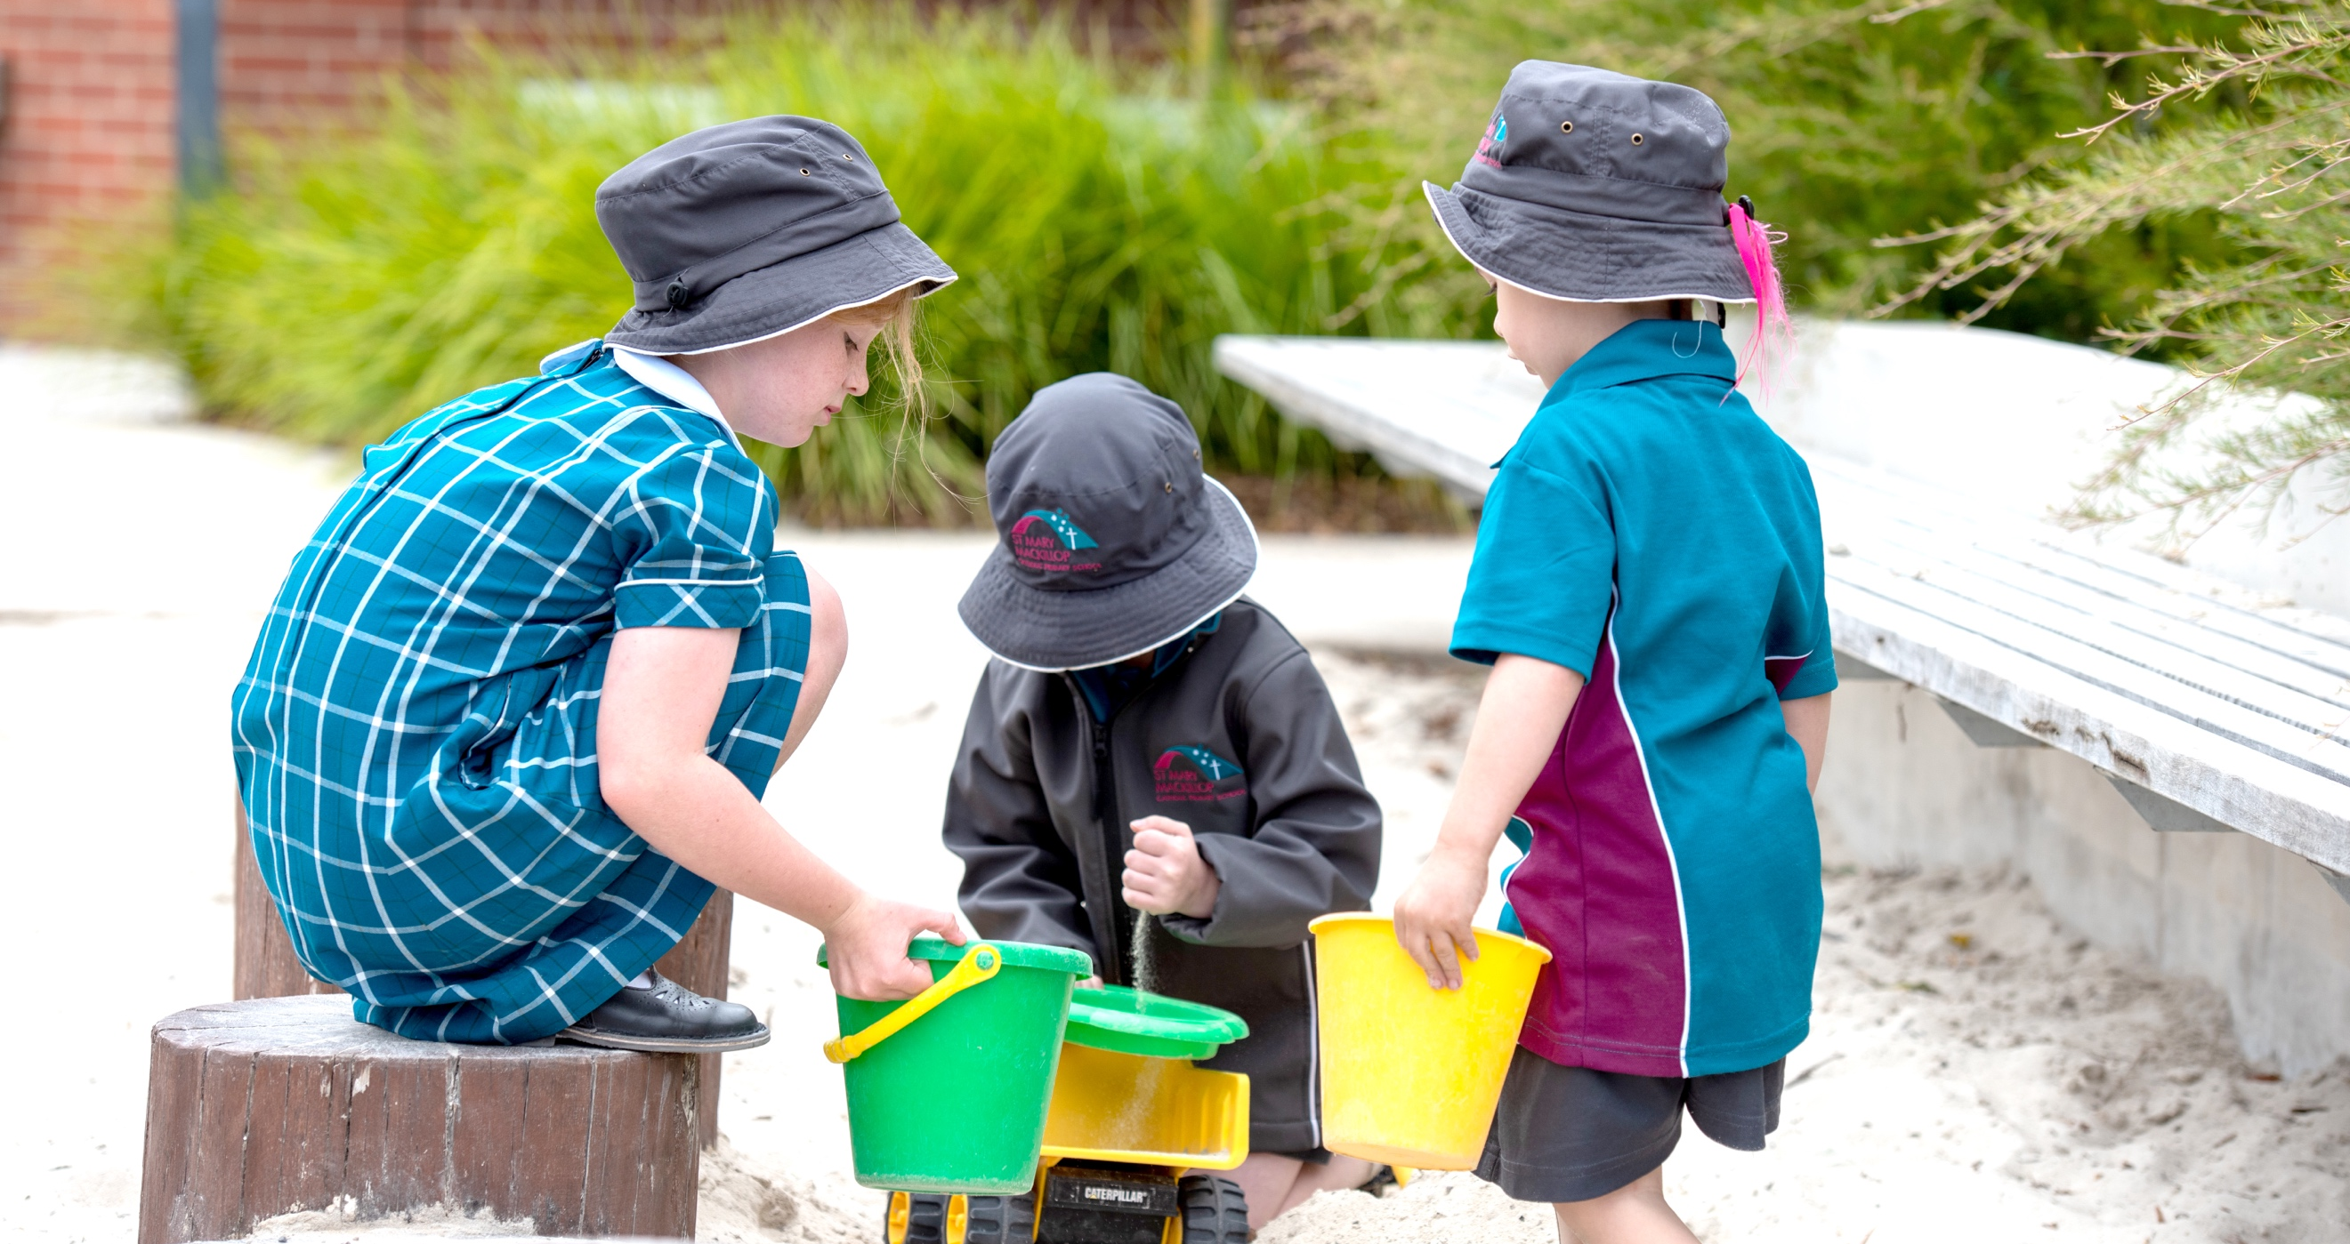
During the second half of recess and lunch break, the Italian
Room is open for “Passive Play”. This is a place for those students
who may not want to be outside. They are able to play with some
quiet toys, colour, draw, build etc in a supervised environment. This is a great place for children and is well
utilised every break time.

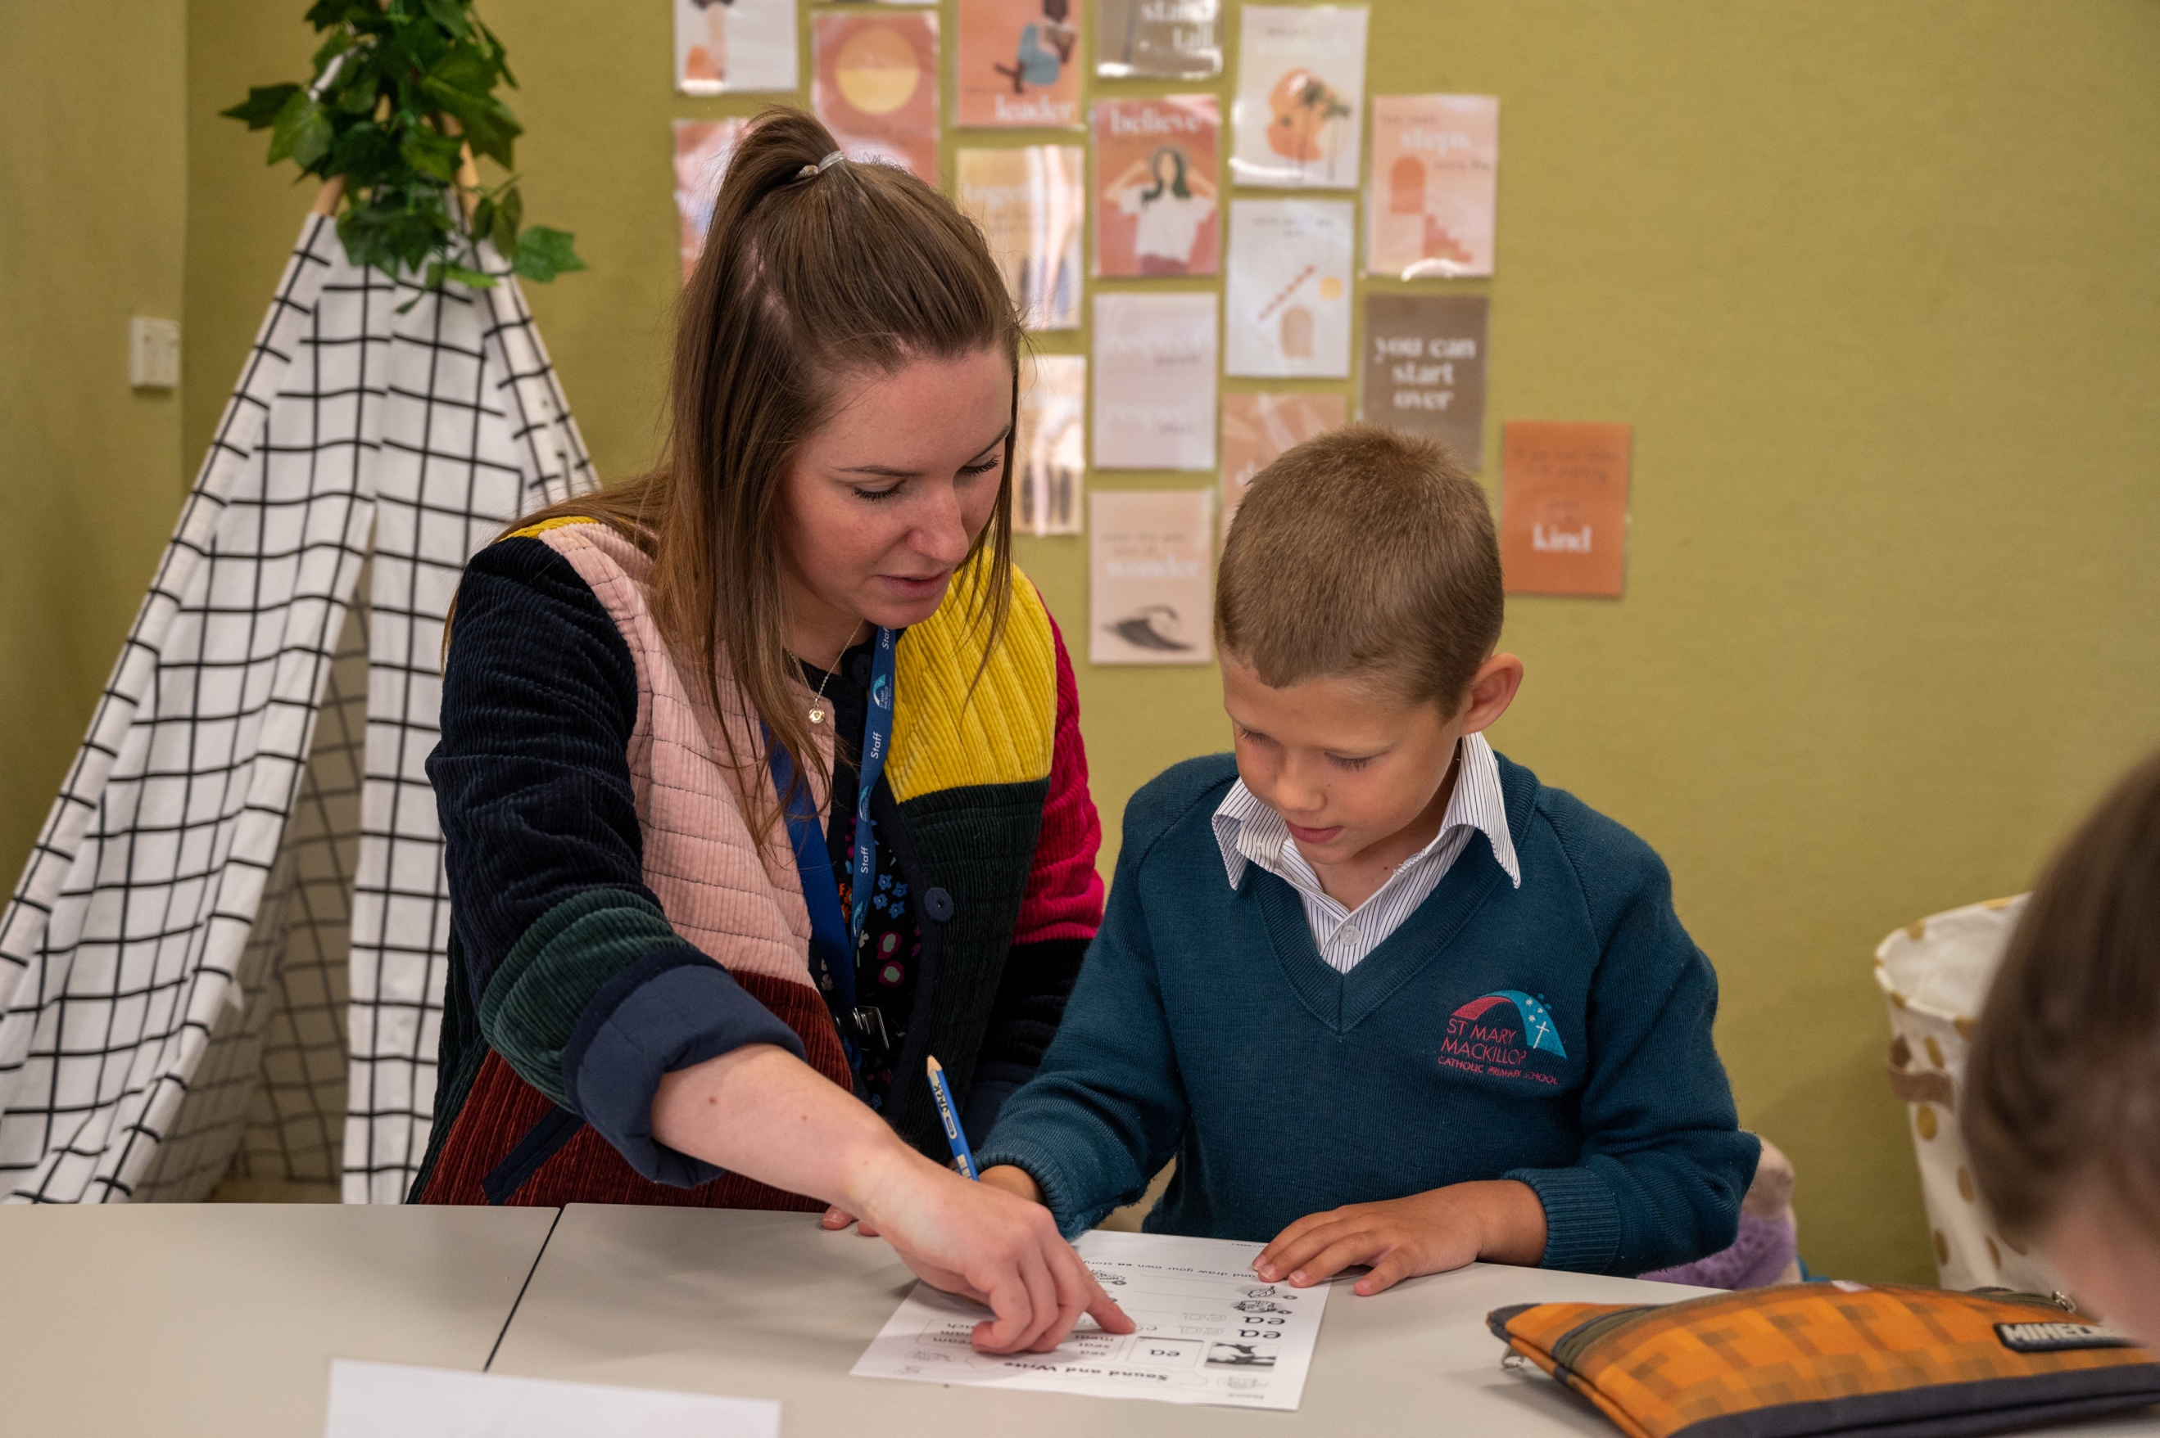
STUDENT HEALTH AND WELLBEING

Active Travel

St Mary MacKillop CPS encourages ‘Active Travel’ of all children and Families. For those children who ride or scoot to school, they are asked to leave their bikes in one of two bike areas – High St and Milton St. Children/parents should provide their own safety chain and lock. Bikes and scooters are brought into the school at the owner's own risk. Bikes or scooters may not to be ridden in the school grounds. Helmets must be worn at all times.

We also encourage those who live close by to walk to school. In partnership with Bicycle Network and the Golden Plains Shire, we have developed two signed safe walking paths to school. Both are approximately 700m from school and have areas where parents can park their car and walk with the children to school. Path One begins at Lyons Park and Path Two from the Council offices on Pope St.

At different times during the year the school will organise Walk to School mornings to help encourage Active Travel. October is Walk to School Month and we will be encouraging Active Travel during this month.

Anaphylaxis

Allergies are becoming more prevalent in our society. ANAPHYLAXIS is a severe, rapidly progressive allergic reaction that is potentially life threatening. The most common allergens in school aged children are peanuts, eggs, tree nuts (e.g. cashews), cow’s milk, fish and shellfish, wheat, soy, sesame, latex, certain insect stings and medications.

Minimising risk protects vulnerable children and reduces opportunities for incidents.

When a child is at school and is at risk of anaphylaxis, parents must:
- Inform school staff of the diagnosis and its cause
- Discuss prevention strategies with the school
- Work with school staff to develop an Anaphylaxis Management Plan in consultation with the child’s medical practitioner
- Provide copies of an ASICA Action Plan for the child, with up to date photographs
- Supply the student’s EpiPen and ensure it has not expired
- Attend the school’s training session, where possible.

At St Mary MacKillop CPS we are committed to:
- Complying with the Ministerial Order 706
- providing, as far as practicable, a safe and healthy environment in which children at risk of an anaphylaxis episode can participate equally in all aspects of the school’s programs.
- raising awareness of allergies and anaphylaxis throughout the community.
- actively involving the parents/guardians of each child at risk of anaphylaxis in assessing risks,
- developing risk minimisation and management strategies for all children.
- ensuring that each staff member and other relevant adults, have adequate knowledge of allergies, anaphylaxis and emergency procedures.
- facilitating communication to ensure the safety and wellbeing of children at risk of anaphylaxis.

We ask that you are very careful in the choice of foods that you include in your child’s recess/lunch and we discourage sharing of food.

We request that you AVOID PEANUT BUTTER, OTHER NUT PRODUCTS as well as EGG sandwiches in your child’s lunch.

Asthma

St Mary MacKillop CPS is on the journey to becoming an accredited Asthma Friendly School. Staff have been trained to treat the symptoms of asthma. All children who have been medically diagnosed with asthma are required to have a current Asthma Action Plan signed by a doctor. A copy of this plan will be filed at the school office and with the child’s teacher.

Asthma Action Plans are to be renewed each year.

Please note: Spacers are recommended for everyone who uses a puffer as it greatly increases the medication reaching the airways. All children should have their own spacer at school clearly labelled with their name.

Parents of children who have asthma medication must fill in an asthma action plan and return it to school.
We request that your child bring their medication together with their own spacer if required to school where it will remain. Any medication that your child brings to school should be labelled correctly with their name and exact dosage. Medication will be stored in the sick bay

We do not use medication past the use by date. Please ensure your child’s medication is current and well within the expiry date.

For further information about asthma management contact Asthma Victoria on (03) 9326 7088 or toll free number 1800 645 130 or www.asthma.org.au.

Bullying and Harassment Prevention

We believe the children at St Mary MacKillop CPS have the right to learn in a safe and happy environment, without the fear of intimidation.

We expect, encourage and support all children to report any bullying incident in which they have been involved as either victims or witnesses. Children may report problems to classroom teacher, teachers on yard duty, principal, deputy principal or parents.

Bullying and Harassment incidents are taken seriously by all staff. At St Mary MacKillop CPS we work from a Restorative perspective when dealing with issues relating to children’s behaviour. For more information about Restorative Practices and how it works please ask at the office for a copy of our policy.

If you have any concerns about bullying please see your child’s teacher as a first step.

Child Safety Standards

St Mary MacKillop CPS is committed to providing a safe environment for all students and young people and takes active steps to protect them against abuse. To achieve this the school has developed and actively enforces Child Safety Strategies to ensure that any person involved in ‘child connected work’ is aware of their obligations & responsibilities for ensuring the safety of all children under their care.

In accordance with requirements of the Victorian Government’s Ministerial Order No 870, St Mary MacKillop CPS maintains a culture of ‘no tolerance’ to child abuse and to support this has established minimum Child Safety Standards.

For more information about our commitment to Child Safety please refer to our Child Safety section of our Website.

Community / Parent Code of Conduct

All Parents and visitors to St Mary MacKillop CPS will be bound by the conditions in our Community/Parent Code of Conduct. All families sign this Code on acceptance of an enrolment offer. A copy of this Community/Parent Code of Conduct can be accessed from our website. A new code is signed each year during the re-enrolment process. Parents are expected to adhere to these conditions and enrolment may be reconsidered due to breaches of this code.

Court Orders

If a family situation is such that the Family Court has made a Parenting Plan/Order, the Principal must be informed of the relevant details. Details of any Residence Orders are particularly vital for the school authorities.

Parents who have separated need to understand that St Mary MacKillop CPS teachers will endeavour to keep the lines of communication open with both parents unless a Family Court Order forbids same. In other words, reports would be available to both parents and Parent/Teacher Interviews would be arranged either jointly or separately as appropriate. Please inform Admin staff and your teacher of your requirements

Copies of current Court Orders must be provided to the school. The school has no jurisdiction to act in a family matter if no court orders exist or if we do not have a copy of one.

Head Lice

Head lice are a common occurrence for children in all schools. If we notice a child with what appears to be head lice we will contact the parent and ask for the child to be collected from school and treated before being returned to school the following day. We ask that all parents be vigilant and check their child’s hair regularly. If you find head lice please let the office know and we will ask all families to check their children’s head.

Advice about the treatment of head lice can be obtained from the pharmacy, or on the Government website.

https://www.health.vic.gov.au/infectious-diseases/head-lice

By signing a child’s Enrolment Form, parents give permission for their child’s hair to be inspected for head lice/nits. Such inspections will take place if such is deemed necessary by school authorities; such permission will remain for the child’s entire enrolment.

Immunisation & Infectious Diseases

An important message for parents regarding protection against infectious diseases.

INFECTIOUS DISEASES

Please note that if children contract certain infectious diseases, the Principal has the right to exclude such children from school for a specified period. For exclusion periods see

https://www2.health.vic.gov.au/public-health/infectious-diseases/school-exclusion/school-exclusion-table

IMMUNISATION.

By law, your child must have an immunisation status certificate to enrol in primary school.

Why immunise

Children starting school are exposed to a large number of people and to a range of potentially dangerous diseases.

Immunisation is a proven and safe way to be protected against diseases that cause serious illness and sometimes death.

Enrolling in primary school is a good time to check your child’s immunisations are up to date.

If your child has not received any immunisations, you must still provide a certificate.

The school keeps a copy of the certificate so that, in the event of a disease outbreak, unimmunised children can be quickly identified and excluded from school until the risk of infection has passed.

If you do not provide the certificate to the school your child may also be excluded from school as their immunisation status will be unknown.

Homeopathic treatment is not a legally recognised form of immunisation and cannot be listed on an immunisation status certificate

COVID Vaccinations

All staff working is schools must be fully vaccinated against COVID – 19

Families are strongly encouraged to have their child fully vaccinated against COVID – 19.

Medication

From time-to-time children require medication to be administered whilst at school. A Medication Authority Form must be completed and signed by the parent prior to any medication being administered. All medication sent to school must be labelled and in its original packaging and sent directly to the office. All students requiring medication will be supervised by a staff member, either the school nurse or other authorised staff members.

Staff cannot administer any medicine to children without written permission on the appropriate medication forms. Medication forms are available from the school office.

The medication policy can be found on our website.

School Counselling Services

St Mary MacKillop CPS has employed the services of a School Psychologist to provide our children with School Counselling services as well as complete assessments that the school deems necessary in consultation with parents. There is an internal process for referring children to the psychologist. Parents are not able to deal directly with the psychologist. If you have concerns, please see your child’s teacher as a first

Before any counselling can be undertaken, appropriate forms need to be completed and returned to the counsellor. There may be a waiting list for service and the counsellor can discuss if other outside services maybe more appropriate.

School Nurse

St Mary MacKillop employs the services of a School Nurse to manage the day to day running of the Sick Bay and delivery of medications etc. The school nurse will be in contact with you if there is an incident in the yard or if your child is sick and needs to be collected from school. For minor incidents and sick bay visits you should receive an Operoo notification explaining why they were there and what treatment was administered.

The school nurse will also follow up with any parent whose child has asthma, anaphylaxis or other medical condition to discuss their treatment plan and request up to date management plans and medication..

School Speech Pathologist

St Mary MacKillop CPS has employs the services of a Speech Pathologist to assist the school provide a more managed approach to conducting assessments that the school deems necessary in consultation with parents as well as upskilling teachers and Learning Support Officers to deliver programs to assist those children who have identified issues. This Speech Therapist will not be conducting individual therapy sessions.

Sick Children

If children are feeling sick, they should be kept at home. Parents are able to give more adequate care and rest to sick children and this assists in reducing the spread of any diseases, illness across the school. It is important to note that our sick bay has limited space. Sometimes sick children will be sent home during the day; such arrangements always involve phone calls to parents/emergency contacts; sick children are never sent home by foot or bicycle.

COVID-19 has meant that there is a greater focus on sick children remaining home until they recover. If your child is showing symptoms of Coronavirus, then you will need to have them tested and let the school know the outcome of any testing.

SunSmart

NO HAT - NO PLAY POLICY

Our SunSmat Policy states that the school enforces a ‘No Hat - No Play Policy’ when the UV Index reaches 3 and above especially in Terms 1 & 4. School hats can be required as early as the end of term 3 and parents will be notified when hats need to be worn. Children are required to wear their school hats and are when outside during these terms. No hats other than school hats permitted to be worn.

School hats are available from Bellarine uniform and the school office.

Support for Students with Additional Needs

An extensive Learning Enhancement Program is provided by the school for children who may need extra support. Support for additional learning needs is considered on a referral basis and parent consultation is always managed by our Learning Diversity or Learning Community Leaders.

Learning Enhancement Teachers

The school employs three Learning Enhancement Teachers in 2023, who will work in the classroom spaces supporting the children who need extra assistance or extension as deemed appropriate by the classroom teachers. The children from time to time may be taken out in small groups to facilitate their learning. This is no different to a teacher taking a small group in their classroom.

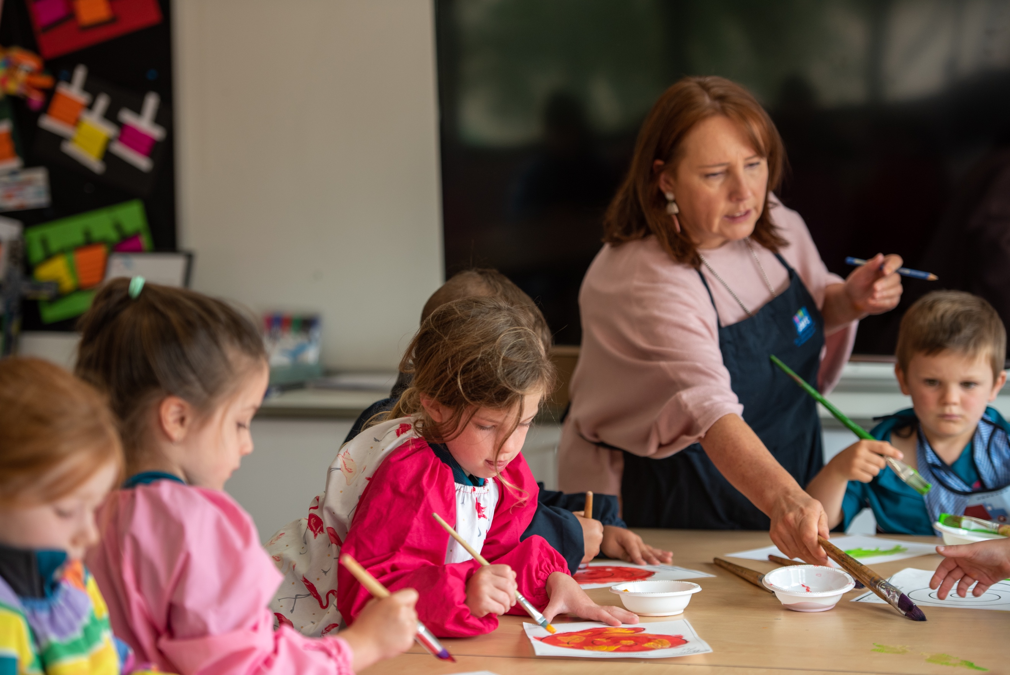
CURRICULUM PROGRAMS

Curriculum

St Mary MacKillop CPS strives to provide a broad education that helps the child to develop fully as a positive member of our school and community. To achieve this, we develop our curriculum to stimulate, challenge and celebrate achievements.

Our curriculum highlights all of the learning areas set out in the Victorian Curriculum and the Catholic Education Commission of Victoria.

Central to our curriculum is Religious Education, which is the basis of all that we do, in the way we interact and treat each other as members of our school community. At St Mary MacKillop CPS we integrate Religious Education into everything we do through our Faith Life Inquiry units.

In an era, where knowledge and skills necessary to obtain knowledge are increasingly more important, we endeavour to develop children with the skills necessary to seek, interpret and manipulate the wealth of information available to them.

Our Teaching and Learning is focused on but not limited to the following areas:
- Religious Education (Through Faith Life Inquiry)
- English
- Mathematics
- Physical Education and Health Education
- Digital Technologies
- The Arts
- Languages other than English (LOTE)
- Inquiry units of work
- STEM (Science, Technology, Engineering and Mathematics)

Camp Program

As part of the Curriculum, St Mary MacKillop CPS will be developing a Camps program from Prep – Year 6. Children in Year 3 and 4 and Year 5 and 6 will travel to an off-site facility for a three-day two-night program. Whilst children in Year Prep to Year 2 will have a variety of long day stays at school.

Camps are arranged to incorporate aspects of the current curriculum content. Camps are compulsory activities as they enhance and strengthen work completed during class time. They also provide an opportunity to develop new friendships and skills that involve developing independence.

The cost of the Grades 3 – 6 camps will be included in the Individual fee charged at the beginning of each year. Camps are a compulsory activity at St Mary MacKillop CPS.

Excursions

At St Mary MacKillop CPS we believe that Excursions and Incursions are an integral part of the educational program and enhance the learning opportunities for students. As part of the educational program teachers will arrange for Excursions or Incursions that enhance the learning and teaching opportunities.

A note will be sent home via Operoo prior to the Excursion or Incursion taking place informing you of the event. Excursions will require you to sign the permission slip attached to the Operoo email for your child to take part. No child will be allowed to leave the school premises without parent permission. The cost of all excursions and incursions is covered in the Individual Curriculum Fee paid each year.

Teachers will endeavour to use the local area as part of their learning programs. On enrolment you signed a local excursion permission form. Teachers may from time to time take the children for a walk in and around Bannockburn.

Interschool Sport

St Mary MacKillop will be participating in the local Geelong Interschool Sports in a variety of different sports. Children from Year 3 – 6 participate in a variety of sports including athletics, cross country, Lightning Premiership etc.

Religious Education

At St Mary MacKillop CPS, all children are given the opportunity to develop their relationship with Jesus Christ and our Church through our Religious Education program that is incorporated into our Faith Life Inquiry Program.

The Archdiocese of Melbourne provides Religious Education Texts ‘To Know, Worship and Love’, which are a guide to, and form, the basis of our Religious Education Curriculum.

Level Masses, School Masses and Liturgies are held periodically.
You are encouraged to attend your child’s level mass or Liturgy to show your support for the importance of this essential aspect of the school’s work.

Prayer is an integral part of school life. All children will be involved in daily prayer celebrations in their classrooms.

Any queries regarding Religious Education at St Mary MacKillop CPS may be directed to the Religious Education Leader.

Reporting Children’s Progress to Parents

The current system of reporting to parents on the progress of children involves at least four communications - two written reports and two 3 Way Conversations held in Terms 1 and 3.. In addition to these opportunities, parents or teachers may choose to arrange special interviews at mutually convenient times should such be considered necessary.

Assessment of children’s progress is an ongoing process. Several formal testing programs are used by the school, including literacy and mathematics screening tests, which are conducted at various times throughout the school year. Various other assessment tools are used at each year level as well as teacher designed assessment pieces.

Formal written reports are sent to parents at the end of Term 2. The report format is consistent with that used and required by State and Federal Education authorities.

Formal written reports are also sent home towards the end of Term 4.

National Testing Program (NAPLAN)

Children in years three and five participate in the National Testing Program (NAPLAN). Formal testing programs are conducted in the school during May. These tests are then marked and collated and fed back to parents in the form of a standard report. Parents of year 5 students are advised to keep this NAPLAN report as you will require it when enrolling into Secondary School.

Sacramental Programs

Sacramental preparation is commenced in Prep and built on throughout the primary school years. Preparation for the reception of the Sacraments occurs as follows:

Year 3 - Reconciliation Year 4 - Eucharist Year 6 - Confirmation

While the school takes some responsibility in the preparation of children for the Sacraments, parents and guardians are also expected to become involved.

All families of children involved in the sacramental programs will be required to participate in the preparation program. Each program is different, but will comprise a parent education aspect, a family preparation aspect and a home based program which parents are expected to complete with their children.

The family preparation aspect of these programs are compulsory, and non attendance may result in a deferment of the reception of the sacrament.

Student Leadership

Our Student Leadership program will include children in the Year 5 & 6 classes. The senior leaders will come from the Year 6 cohort and Year 5 children will be able to participate in other leadership roles.

Towards the end of the year the Year 5 children will take part in a Leadership Program which will assist us in selecting our leaders for the following year.

Transition Programs

Year Six to Secondary

The school conducts a thorough transition program for all students in year six. Year six teachers work with Secondary School Co-ordinators to ensure that all aspects of the student’s enrolment are covered.

Kindergarten to Prep

The School conducts a comprehensive transition program that involves:

- Meetings with the Principal and Deputy Principal to discuss enrolment.
- Numerous visits to school by incoming prep children including playdates, screening tests and Literacy testing
- Visits to kindergartens by St Mary MacKillop staff
- Orientation programs for new preps and their families

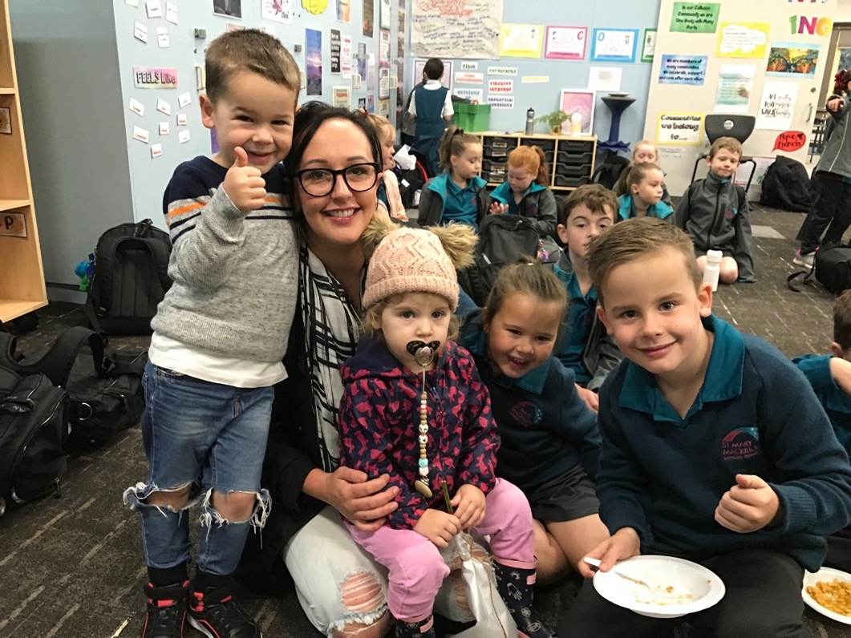
PARENT & COMMUNITY INVOLVEMENT

Classroom Helpers

Classroom helpers are always welcome at St Mary MacKillop. In 2023 the school will run a Classroom Helpers Program where we will discuss the role of the Classroom helper and things like confidentiality as well as upskilling parents in how to assist children who need assistance.

To become a Classroom helper, you need to have a Working With Children Check. If you do not have one of these then you can apply online for one before school begins next year.

Communication

Newsletter
The school produces a Newsletter every fortnight on a Friday. The Newsletter holds a vast amount of information about the school, reports of recent events and what is happening in the coming weeks. Please make a habit of reading the Newsletter so that you can remain up to date on all that is happening at school.

Our newsletter is digital and contains videos and photo galleries as well as information from Fr Joseph and the Parish. A link to our latest newsletter will be sent out via Operoo. Our newsletter is a private newsletter and will not be loaded to our website. If you wish for grandparents or other family members to receive the newsletter, you can share the link provided each time with them.

Operoo
At St Mary MacKillop CPS we use the Operoo App as a way of managing student medical details and excursion and other permission notes. Operoo will be our main source of communication with families in 2023 and Seesaw will be retained for classroom communication.

Operoo is essentially a health and safety system that automatically keeps medical and emergency details up to date for us. It makes these important details instantly available to teachers and other authorized staff on their mobile devices in an emergency so they know who to call, what to do, or what to tell an ambulance paramedic. Operoo automates the permission and consent form process too and can collect any other information.

Information on how to enroll in Operoo will be given to you upon enrolment.

Social Media
St Mary MacKillop has a Facebook and Instagram presence for the communication of school related activities and to promote the school within the community locally and more widely. If you are making comments in regard to a post, those comments should be in keeping with the ethos of St Mary MacKillop school. The administrators reserve the right to delete comments that do not adhere to this.

Parents and Friends Association

The Parents and Friends Association (P&F) provides a network for parents to participate in activities and decision-making processes at St Mary MacKillop CPS. It works to benefit our children, the school and our community. Some of its many functions include:

- supporting the school with social activities to help build community spirit.
- helping the school financially by raising funds for specific/general purposes.
- members helping to organise the school maintenance.
- other roles and duties as the needs arise.

Meetings dates and times for 2023 will be listed on our Google Calendar and will be advertised in the newsletter and the Parent Calendar. All parents are welcome and encouraged to attend.

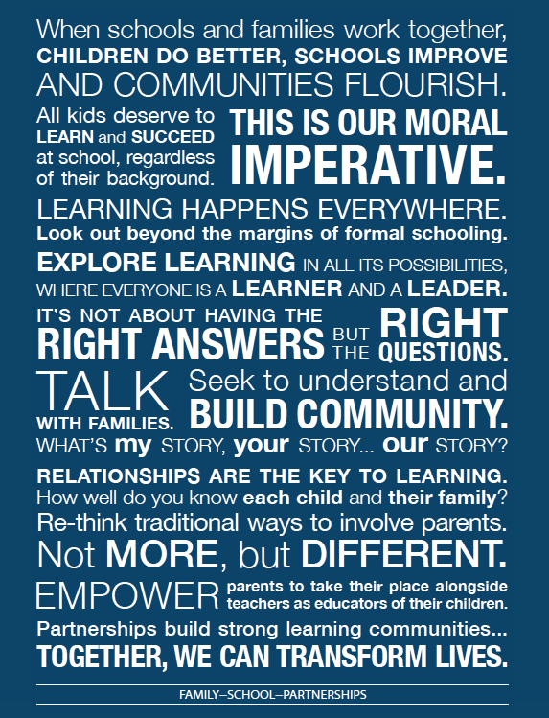
At St Mary MacKillop CPS we believe the following statement and work to make it a reality with our families and community. We hope you will join us

