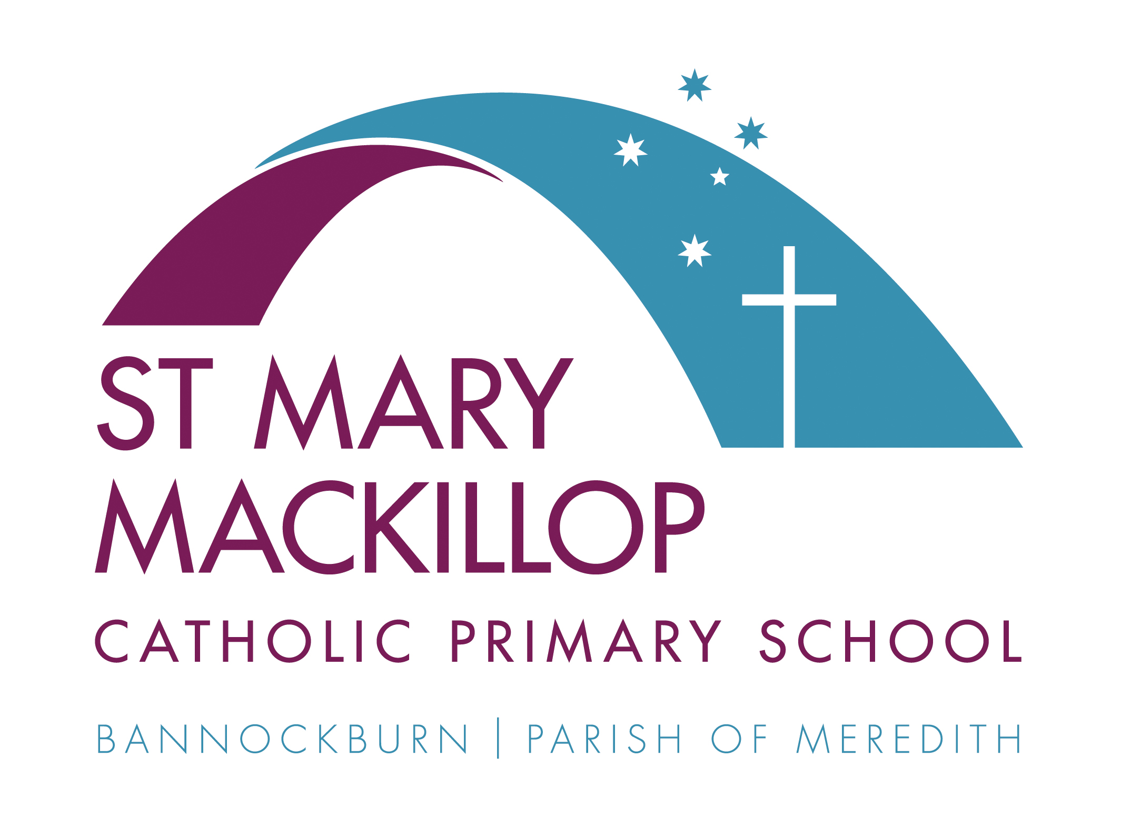

St Mary MacKillop Catholic Primary School
Medical Management Communication Plan

How staff members and volunteers are informed about students with medical needs

Staff Members and volunteers
General information about how communication will occur and where to find the medical management and health plans for students who have a diagnosed health care need, allergy or relevant medical condition and how staff will be informed of requirements.
Prior to a child with a diagnosed health care need, allergy or relevant medical condition commencing at St Mary MacKillop Catholic Primary School, a Medical Management Plan authorised by the treating medical / health practitioner is required so that the school can enact appropriate care. [School name] will provide each staff member and volunteer (as appropriate) with access to the Medical Management Policy and teachers will be notified of students that have a Medical Management Plan and associated Student Health Plan and the practices required.
Parents are informed of how they can communicate any changes to the health care needs of their child through the enrolment policy, and regular reminders provided through the school newsletter, Program Support Group Meetings, Parent Teacher Meetings/Year level briefings, camps and excursion notifications.

Policies and Procedures
St Mary MacKillop Catholic Primary School provides staff with information about the requirements of the managing health care needs in the following policies, procedures and guidance materials.
Staff are required to be familiar with the following policies and procedures.
Item | Location | Applicable to | Updated
Medical Management Policy | Safesmart Portal on Staff Intranet Page | All students with medical and/or health needs | June 2021
Administration of medication procedures | Safesmart Portal on Staff Intranet Page | All students with medical and/or health needs | June 2021
Medication Authority Form | Safesmart Portal on Staff Intranet Page | All students with medical and/or health needs | June 2021
Student Health Support Plan | Safesmart Portal on Staff Intranet Page | All students with medical and/or health needs | June 2021
Medical Management Plan Template | Safesmart Portal on Staff Intranet Page | All students with medical and/or health needs | June 2021

Communication protocols
Staff, volunteers and parents are informed about school practices to manage medical conditions in the following ways:
What will be communicated? | Date/Frequency e.g. termly, annually etc | How will this communication occur? / What is the process?
Parents are informed of how they can communicate medical needs and any changes to the health care needs of their child. | On enrolment  Each Term  Update Operoo prior to excursion/camp  Beginning of each year | This is done on enrolment and via the Medical Management Policy. Enrolment Packs include advice about the requirement to provide relevant medical information and diagnoses.  A notice placed in the school newsletter each term advising modes of communication within the school about medical conditions or administration of medication etc..  All parents of children will be asked to update advice related to any health care needs prior to all excursions and camps.  Parents of children with existing Medical Management Plans and Student Health Plans are provided with a regular (generally annual) reminder of the requirement to provide the school with any updates/ changes to their child’s health care needs
All school staff and volunteers are provided with information about the requirements for managing student health care needs | Annual Teacher briefings  As required  Annual Teacher Briefings / as required | School staff and volunteers are provided with information as part of the induction into the school, on the Medical Management Policy and Administration of Medication Procedures – including in the staff induction / induction manual, as well as annual teacher briefings.  Additional staff meetings/training sessions to update staff on changes in policies, process for review of medical management, updated risk mitigation plans or newly diagnosed conditions.  Staff are provided with details about:  - where the Medical Management Plans, Student Health Plans and medication are located  - Protocols for the use of children’s health care information for the purpose of the health, safety and wellbeing of the child  - Protocols for contacting an additional First Aid Officer
All relevant school staff are provided with training about the requirements for managing student health care needs |  | Sufficient Staff members have current first aid certification  All school staff have certification in the management of anaphylaxis  All school staff and volunteers are provided with a six-monthly anaphylaxis briefing  Identified Staff Members participate in annual CPR training  Identified Staff Members participate in diabetes management, asthma management,  Relevant school staff are provided with specialised training if required to implement the medical management plan.
Casual Replacement Teachers and Emergency Teachers are informed of Medical Management Policy and Administration of Medication Procedures |  | All casual replacement teachers, specialist teachers, and emergency teachers and relevant volunteers are provided with:  - information as part of the induction into the school, in the staff induction manual  - Information pertinent to their engagement or role and students that they will supervise

